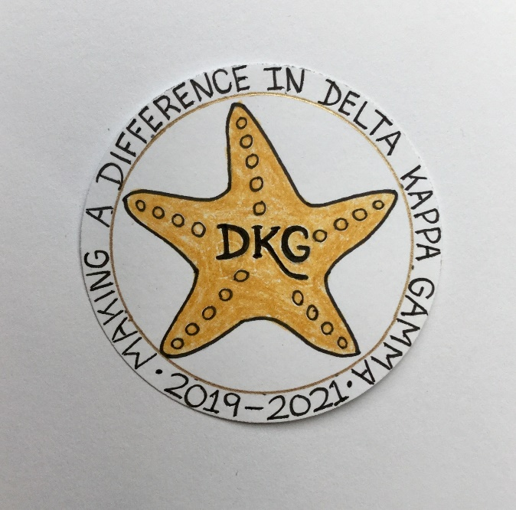
Alpha Delta Newsletter - - April, 2020
Illinois State Organization, ALPHA DELTA CHAPTER # 28 Cook County, Illinois
Mission: The Delta Kappa Gamma Society International promotes professional and personal growth of women educators and excellence in education.
Vision: Leading Women Educators Impacting Education Worldwide

Chapter Theme: Making a Difference
Chapter Focus: Sharing our Choices for Action

Dear Alpha Delta Chapter Members,

This is a very unique time for citizens around the world. We are all encouraged to follow “Best Practices” as we fight this Coronavirus Pandemic, including frequent hand washing, covering the mouth when coughing and sneezing, social distancing and remaining at home. Many meetings and events have been cancelled to avoid spreading the virus. Let’s continue to do our part to help “flatten the curve” and help halt this pandemic.

*The Cook County Coordinating Council Annual Luncheon held on March 7th was delightful! There was great fellowship, a delicious lunch, and creative chapter baskets were raffled off.
The speaker from the WINGS Program was quite informative and received many donations. A student teacher received the Outstanding Student Teacher Award along with many school items and supplies. The Legislative Award was presented to Illinois State Representative Michelle Mussman. All chapter Achievement Awardees were announced. Our 2020 Awardee was Diane Zmaczynski. Her daughter and son attended and received Diane’s award.

*Our very next event was to be the Illinois State Organization Convention on Friday through Sunday, April 24-26, 2020 at the Marriott Airport St. Louis, in St. Louis, MO. Our International Visitor was DKG International President Cathy Daugherty! HOWEVER, due to the Coronavirus, the convention has been CANCELLED! State President Bev Johns has informed us that the planned workshops will be held next year during the April 23-25, 2021 Convention at the Doubletree in Oakbrook. The Memorial Ceremony will be held for two years, as well as the Recognition for longevity of members. Achievement Award winners for 2020 and 2021 will be announced in 2021. International President Daugherty is now scheduled to attend our Executive Board meeting in September, 2020 in Bloomington. All scholarship, stipend, Florence Cook and Grant-in-Aid recipients will be featured in the Newscaster and their checks mailed.

*CANCELLED also was the Leadership Academy Collaborative Workshop and Training for four of our incoming Chapter Leaders for the 2020-2022 Biennium which was to be held on Friday, April 24, 2020 at the Marriott Airport St. Louis during the State Convention. Two others were to attend the training on June 6, 2020 at Bradley University – which at this time is still scheduled.

*Our fifth chapter meeting of the year and final meeting of this biennium scheduled for May 16, 2020 will also be cancelled. We were to have the Installation of Officers, the Induction Ceremony for a new member as well as the Memorial Ceremony for Dr. Kyle Wade at this meeting. These will be held at a later date. Remember – we elected our 2020-2022 Slate of Officers during the January 25th meeting and they are official and have begun planning for their two summer Executive Board meetings and the 2020-2022 biennium.

*The annual membership renewal form will be mailed in early April. Please sign and return your form (whether you make any updates / corrections – or not) along with your check to Treasurer Lynne White.

*We truly thank member Ann Collins for her gracious invitation to attend a meeting/outing at her home in Union Pier, Michigan sometime during the warmer months. Although we had to cancel at this time, Ann said she hopes we will join her in the future when “things are better.”

*Consider joining the State Facebook page at: DKG-Illinois key women educators. Illinois State Organization President Bev Johns has encouraged us to LIKE the State Facebook page where she posts DKG and Illinois chapters’ news every day.

*Visit the chapter website at www.alphadelta-il.weebly.com and read the book reviews of over 45 books to help select your reading choices. Check-out the Photo Gallery with pictures from our meetings. Then take a peek at the Showcasing Our Members page.

*For All Shoppers – DKG receives a small donation from Amazon when we shop through smile.amazon.com. 0.5% of your purchase will be donated to DKG Supporting Corporation which supports many of our DKG funds. To start your AmazonSmile account, go to dkg.org and click on About Us>How To Become A Member>Discounts. Then, select DKG Supporting Corporation as your charity. HAPPY SHOPPING!

*Reminders /Upcoming Events – Set your calendars – these events so far are still scheduled:

- Tuesday-Thursday, June 23-25, 2020
Creative Arts Retreat at Allerton Park, in Monticello, IL. Registration forms are available on the State Website.
- Tuesday-Saturday, July 7-11, 2020
DKG International Convention, Philadelphia, PA.

Have you spoken to a chapter member lately?
Have you missed seeing someone at our meetings? Please check and see if anyone needs a ride to a meeting. How nice it would be to receive a call from someone who cares!

Happy Birthday Greetings
April – Denise Gamble, Samantha Denson, Rita Dawkins
May – Barbara Richey, Joan Reed, Barbara Martin, Florence Marcus,
Patricia Mizerka, Donna Soukup, Rosemary Smith, Jeanette McGowan

Wishing good health to Everyone
Patricia Gaines, President

