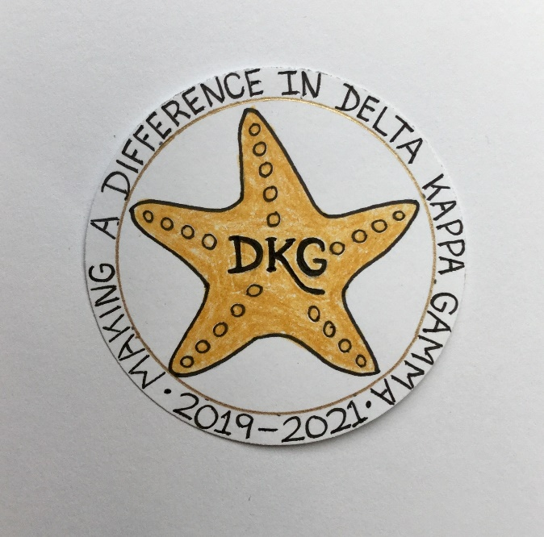
Alpha Delta Newsletter - - May, 2020
Illinois State Organization, ALPHA DELTA CHAPTER # 28 Cook County, Illinois
Mission: The Delta Kappa Gamma Society International promotes professional and personal growth of women educators and excellence in education.
Vision: Leading Women Educators Impacting Education Worldwide

Chapter Theme: Making a Difference
Chapter Focus: Sharing our Choices for Action

Dear Alpha Delta Chapter Members,

*Our days and nights are filled with finding “things to do” as we continue “social distancing,” wearing a mask and gloves when going out, but remaining at home as much as possible. Following the guidelines and using the healthy practices of frequent hand washing, and covering the mouth when coughing and sneezing are crucial. This Coronavirus Pandemic has challenged us all to find constructive ways to manage. Reading, playing games, enjoying TV programs, gardening, and connecting with others by phone or electronically are excellent ways to pass the time. Well-being calls can make a difference, so let’s all check on each other.

*With so many meetings and events being cancelled to avoid spreading the virus, to help “flatten the curve” and to halt this pandemic, our DKG State Organization has offered us the use of electronic means (Zoom and Conference Calling) as an alternative. Some of you may be familiar with “Go-to-Meeting” which International has offered to all the state organizations for several years. State President Bev Johns has conducted many sessions using all three. She has purchased the Zoom and Conference Calling package that includes more safeguards and security for Illinois chapters to use. This could be an opportunity for President Bev to “sit-in” on our meetings, as well. We will let you know more as details develop.

*Our International Visitor was to be the DKG International President Cathy Daugherty during the “cancelled” Illinois State Organization Convention in April at the Marriott Airport St. Louis, in St. Louis, Missouri. State President Bev Johns has informed us that International President Daugherty is now scheduled to attend our Executive Board meeting in September, 2020 in Bloomington. Also, the planned workshops for 2020 will be held next year during the April 23-25, 2021 Convention at the Doubletree in Oakbrook. The Celebration of Life Ceremony will be held for two years, as will the Recognition for longevity of members. Achievement Award winners for 2020 and 2021 will be announced in 2021. All 2020 scholarship, stipend, Florence Cook and Grant-in-Aid recipients will be featured in the Newscaster and their checks mailed.

*The Leadership Academy Collaborative Workshop and Training for our incoming Chapter Leaders for the 2020-2022 Biennium is now scheduled to be held in Bloomington in September, prior to and immediately after the Fall State Executive Board Meeting. There will be two sessions to choose from. Members may select the first one which will be on Friday, September 25, 2020 from 1:00 to 4:00 pm or the Saturday, September 26th session from 1:00-4:00 pm.

*We, of course, cancelled our May 16, 2020 meeting. Therefore, the Installation of Officers, the Induction Ceremony for new members, as well as the Memorial Ceremony for Dr. Kyle Wade will all be held at a later date. Please Note - A new International item regarding Membership – in the Constitution, Article lll, Section A.2 states that “An individual becomes a member of the Society when she pays her dues.” In the past, an individual became a member when inducted. Remember also – we elected our 2020-2022 Slate of Officers during the January 25th meeting and they are official and have begun planning for their two summer Executive Board meetings and the 2020-2022 biennium.

*The annual membership renewal form was mailed in early April. Please select the committee you wish to serve on, sign and return your form (whether you make any updates / corrections – or not) along with your check to Treasurer Lynne White. We are looking forward to another great DKG year!

*Consider joining the State Facebook page at: DKG-Illinois key women educators.

*We hope you have visited the chapter website at www.alphadelta-il.weebly.com and we encourage you to tell your friends all about us!

*For All Shoppers – DKG receives a small donation from Amazon when we shop through smile.amazon.com. 0.5% of your purchase will be donated to DKG Supporting Corporation which supports many of our DKG funds. To start your AmazonSmile account, go to dkg.org and click on About Us>How To Become A Member>Discounts. Then, select DKG Supporting Corporation as your charity. HAPPY SHOPPING!

*Reminders /Upcoming Events – Set your calendars –so far, these events are still scheduled:

- Tuesday-Thursday, June 23-25, 2020
Creative Arts Retreat at Allerton Park, in Monticello, IL.
- Tuesday-Saturday, July 7-11, 2020
DKG International Convention, Philadelphia, PA.
- Wednesday, August 5, 2020
Celebrating Key Women Educators, Sleepy Creek Vineyard, East of Champaign, IL.

Happy Birthday Greetings

May – Barbara Richey, Joan Reed, Barbara Martin, Florence Marcus,
Patricia Mizerka, Donna Soukup, Rosemary Smith, Jeanette McGowan
June – Joyce Kelly, Lynne White, Mary Jane Riopelle,
Mary Ann Clancy, Lorraine Stastny, Valerie Davis, Loretta Nolan

Wishing good health and safety to ALL!
Patricia Gaines, President

