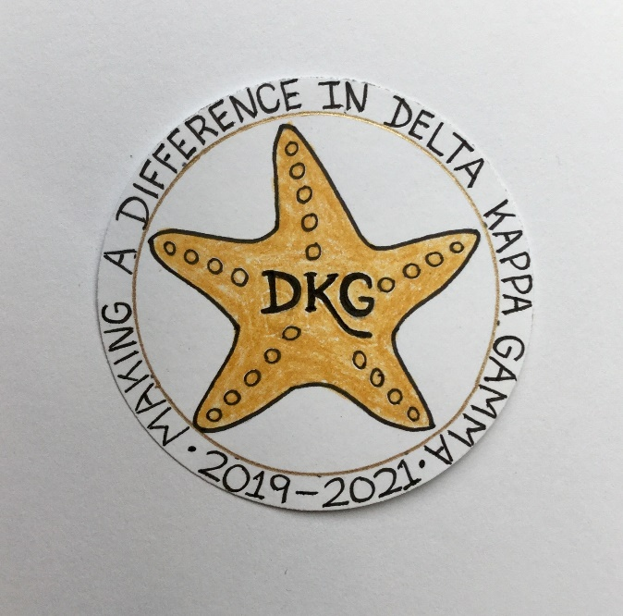
Alpha Delta Newsletter - - June, 2020
Illinois State Organization, ALPHA DELTA CHAPTER # 28 Cook County, Illinois
Mission: The Delta Kappa Gamma Society International promotes professional and personal growth of women educators and excellence in education.
Vision: Leading Women Educators Impacting Education Worldwide

Chapter Theme: Making a Difference
Chapter Focus: Sharing our Choices for Action

Dear Alpha Delta Chapter Members,

*As we come to the end of our 2018-2020 Biennium, I want each of you to know how much
I value and appreciate your dedication. You embraced and displayed our chapter theme, Making a Difference, and our chapter focus, Sharing our Choices for Action while attending meetings, conducting business, supporting worthwhile programs and projects, mentoring, and giving donations to children, students and teachers. A special thank-you is extended to the outgoing officers, President Patricia Gaines, 1st VP Donna Soukup, 2nd VP Brenda Harris, Recording Secretary Mary Jane Riopelle, Corresponding Secretary Christiane Jochimski, the committee chairpersons and every member. Our chapter is so fortunate that Treasurer Lynne White and Webmaster Kimberly Malinowski, who both complete their work so very well, will continue to serve.

*Congratulations to our newly elected 2020-2022 officers, Co-Presidents Cindy Roder and Donna Soukup, 1st VP Brenda Harris, 2nd VP Christiane Jochimski, Recording Secretary Mary Jane Riopelle, and Corresponding Secretary Luba Johnson. They are working with State President Bev Johns and preparing for a very new way of conducting chapter business. Options include using Zoom and Conference Calling. As we receive emails of scheduled listings from the State Organization for Conference Calling and Zoom meetings, sessions and trainings, they will be forwarded to members.

*The following upcoming events have been cancelled:

- 1) Tuesday-Thursday, June 23-25, 2020
Creative Arts Retreat at Allerton Park, in Monticello, IL. Members may receive refunds OR they may apply them to the next Creative Arts Retreat in 2021.

- 2) Tuesday-Saturday, July 7-11, 2020
DKG International Convention, Philadelphia, PA. Members should apply NOW for their refund. Three choices are available: 1) full refund 2) apply full refund toward 2022 International Convention event 3) donate full refund to the DKG International Educators Foundation

*REMINDER - DKG International President Cathy Daugherty will attend the State Executive Board meeting in September, 2020 in Bloomington. The Leadership Academy Collaborative Workshop and Training for our incoming Chapter Leaders for the 2020-2022 Biennium will also be held in Bloomington in September, prior to and immediately after the Fall State Executive Board Meeting. There will be two sessions to choose from. Members may select the first one which will be on Friday, September 25, 2020 from 1:00 to 4:00 pm or the Saturday, September 26th session from 1:00-4:00 pm. Co-Presidents Cindy and Donna will send details to those who will attend. The Women in the Arts Committee will also have the Art Mart on both Friday and Saturday during this Executive Board weekend.

*Your annual membership renewal form was mailed in early April. After you select the committee you would like to serve on, please sign and return the form – whether or not you make any updates or corrections - along with your check to Treasurer Lynne White. We are looking forward to another great DKG year!

*Consider joining the State Facebook page at: DKG-Illinois key women educators.

*We hope you have visited the chapter website at www.alphadelta-il.weebly.com and we encourage you to tell your friends all about us!

*For All Shoppers – DKG receives a small donation from Amazon when we shop through smile.amazon.com. 0.5% of your purchase will be donated to DKG Supporting Corporation which supports many of our DKG funds. To start your AmazonSmile account, go to dkg.org and click on About Us>How To Become A Member>Discounts. Then, select DKG Supporting Corporation as your charity. HAPPY SHOPPING!

*Reminder /Upcoming Events – Set your calendars –so far, these events are still scheduled:

- Wednesday, August 5, 2020
Celebrating Key Women Educators, Sleepy Creek Vineyard, East of Champaign, IL.

- Friday – Saturday, September 25-26
Illinois State Organization Executive Board Meeting, Holiday Inn & Suites,
Bloomington, IL
- Leadership Academy Collaborative Workshop, Holiday Inn & Suites, Bloomington, IL

Happy Birthday Greetings

June – Joyce Kelly, Lynne White, Mary Jane Riopelle,
Mary Ann Clancy, Lorraine Stastny, Valerie Davis, Loretta Nolan
July – Nancy Mayer, Brenda Duncan, Cindy Roder
August – Ruth Ortigoza, Li-Wei Peng, Dorothy (Judy) Flynn, Angela Thomas

I hope everyone continues using healthy practices to stay safe and well.
Wishing good health and safety to You and your family!
Patricia Gaines, President

