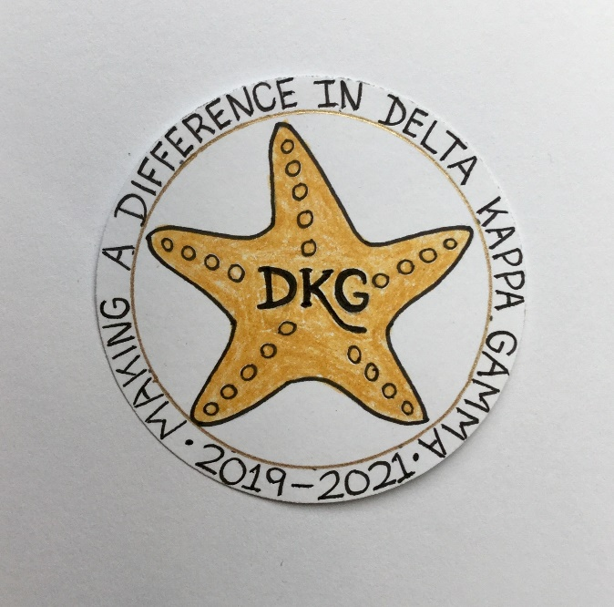
Alpha Delta Newsletter - - August, 2019
Illinois State Organization, ALPHA DELTA CHAPTER # 28 Cook County, Illinois
Mission: The Delta Kappa Gamma Society International promotes professional and personal growth of women educators and excellence in education.

Vision: Leading Women Educators Impacting Education Worldwide

Dear Alpha Delta Chapter Members,
Here’s hoping these “lazy days of summer” have brought lots of time for reading, gardening, exercising and much needed relaxation! Thanks to each of you for renewing your membership by the new deadline, June 30th. This allowed Treasurer Lynne to submit everything on time. Henceforth, we will follow the same schedule.

“Making a Difference in Delta Kappa Gamma” is the theme selected by our 2019-2021 Illinois State Organization President, Beverley Johns. Her first event, Celebrating Key Women Educators: Making A Difference is on August 22, 2019 at the Sleepy Creek Vineyard in Fairmount, IL (east of Champaign-Urbana). The cost is $20 for dinner, wine and a great speaker, Topper Steinman. Check the email and flyer sent last Saturday to contact President Bev Johns or Kammie Richter. Vendors will also be available for your shopping pleasure!

The State Literacy Committee has decided upon the following books to be discussed at the 2020 Convention and the 2021 Convention. In 2020, the fiction book is Lilac Girls by Martha Hall Kelly and the non-fiction book is Educated: A Memoir by Tara Westover. During the 2021 Convention, the fiction book is Where the Crawdads Sing by Delia Owens and the non-fiction book is The Day the World Came to Town: 9/11 in Gander, Newfoundland by Jim DeFede. The discussions at Convention are always lively and informative.

The chapter Executive Board is continuing to plan for 2019-2020, the 2nd year of our Alpha Delta Chapter biennium. Our Saturday meeting dates are September 28, 2019, November 2, 2019, December 14, 2019, January 25, 2020 and May 16, 2020. Please add them to your calendar. There will be more details later.

*** Best Wishes to our Newlywed – Angela Thomas! After a beautiful ceremony and reception, the lovely couple, Derrick and Angela spent a week honeymooning in Puerto Vallarta!

Reminders and Upcoming Events – Please set your calendars:

- Yearbooks will be distributed on September 28, 2019 at our first chapter meeting. Remember to invite a friend or two to join us! If anyone needs a ride to a meeting, please let us know.

- The Chapter Memorial Service for our dear member, Carole J. Ireland, who passed on March 5, 2019, will be held on November 2, 2019. She will be included in the 2020 Illinois State Organization Celebration Service at the State Convention in St. Louis. Memorial donations may be sent to Treasurer, Lynne White.

- To All CCCC Chapter Achievement Awardees – We are still looking for the names of the Cook County Coordinating Council Chapter Achievement Awardees for the following years: 2003; 2004; 2008; and 2010. PLEASE LOOK on the back of your award medallion - as the year may be engraved on it or CHECK the date on your certificate. Then, please notify President Pat - ASAP - to confirm your date.

- Have you spoken lately to a chapter member? Is there someone whom you have missed seeing at our meetings? Perhaps it was someone you sponsored or who sponsored you. How nice it would be to receive a call from someone who cares!

Happy Birthday Greetings

August – Ruth Ortigoza, Li-Wei Peng, Dorothy (Judy) Flynn, Angela Thomas

September – Gretchen Alexander, Marie Feltus

Have a wonderful summer!

Pat Gaines

