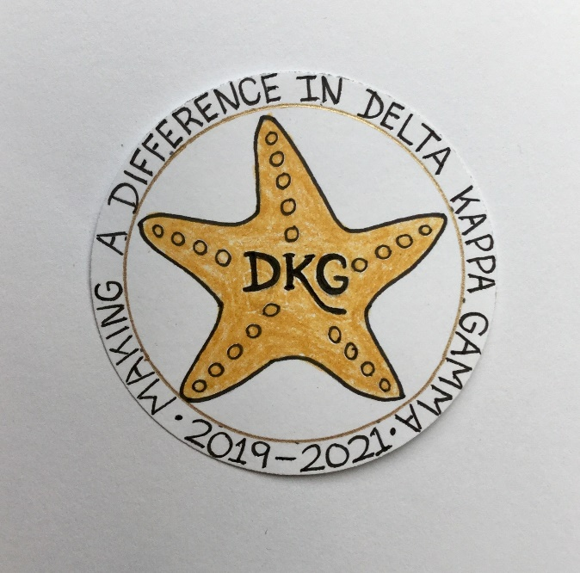
Alpha Delta Newsletter - - September, 2019
Illinois State Organization, ALPHA DELTA CHAPTER # 28 Cook County, Illinois
Mission: The Delta Kappa Gamma Society International promotes professional and personal growth of women educators and excellence in education.

Vision: Leading Women Educators Impacting Education Worldwide

Chapter Theme: Making a Difference

Chapter Focus: Sharing our Choices for Action

Dear Alpha Delta Chapter Members,
As our lazy, hazy days of summer are winding down and preparations for “back-to-school” surround us, may feelings of accomplishments and success be with you each day.
We are looking forward to seeing you on Saturday, September 28, 2019 at Jedi’s Garden Restaurant. Join us and enjoy genuine spiritual fellowship! We will share DKG news, receive chapter yearbooks, and discuss plans for this year. Representatives from the Play Smart Literacy program will give a presentation. Meeting announcements are in the mail. Please consider inviting a friend – to this and every meeting!

“Making a Difference in Delta Kappa Gamma” is the theme selected by our 2019-2021 Illinois State Organization President, Beverley Johns. Note her beautiful “Starfish” Logo (above). Cindy Roder and President Pat will attend the Executive Board meeting in Bloomington, IL on September 20-21, 2019 and share the news during our September 28th chapter meeting.

The State Literacy Committee has decided upon the following books to be discussed at the 2020 Convention and the 2021 Convention. In 2020, the fiction book is Lilac Girls by Martha Hall Kelly and the non-fiction book is Educated: A Memoir by Tara Westover. During the 2021 Convention, the fiction book is Where the Crawdads Sing by Delia Owens and the non-fiction book is The Day the World Came to Town: 9/11 in Gander, Newfoundland by Jim DeFede. The discussions at Convention are always lively and informative.

The chapter will have five (5) Saturday meeting dates. We hope to see YOU and your guests on September 28, 2019, November 2, 2019, December 14, 2019, January 25, 2020 and May 16, 2020. Please add them to your calendar. Check your yearbook for all the details.

There will be three (3) opportunities for the new Chapter Leaders for the 2020-2022 Biennium to attend training from our State Leaders. They may attend the Leadership Academy Collaborative Workshop (formerly known as Chapter Leadership Training) one day before Convention on Friday, April 24, 2020 at the Marriott Airport St. Louis. A second opportunity will be at Bradley University on June 6, 2020 and the third one will be at the IEA Office in Bloomington-Normal on July 16, 2020.

Reminders and Upcoming Events – Please set your calendars:

- Yearbooks will be distributed on September 28, 2019 at our first chapter meeting. Remember to invite a friend or two to join us! If anyone needs a ride to a meeting, please let us know.

- The DKG, Illinois, Legislative Seminar will be held at the Lincoln Library, The Public Library of Springfield, IL, 326 South 7th Street, Springfield, IL on Saturday, October 26, 2019. Time: 10:15 A.M. to 4:00 P.M. Cost: $36.00 - which includes a light breakfast, lunch and materials. Forms are on the State Website at www.deltakappagamma.org/IL/.

- The Chapter Memorial Service for our dear member, Carole J. Ireland, who passed on March 5, 2019, will be held on November 2, 2019. She will be included in the 2020 Illinois State Organization Celebration Service at the State Convention in St. Louis. Memorial donations may be sent to Treasurer, Lynne White.

- Saturday, March 7, 2020 11:30 A.M.
Cook County Coordinating Council Annual Awards Luncheon,
Wilmette Golf Club, 3900 Fairway Drive, Wilmette, IL 847-256-9777

- Friday-Sunday, April 24-26, 2020
Illinois State Organization Convention, Marriott Airport St. Louis, in St. Louis, MO

- Tuesday-Thursday, June 23-25, 2020
Creative Arts Retreat at Allerton Park, Monticello, IL. Forms are available on the State Website. Registration is OPEN now.

- Tuesday-Saturday, July 7-11, 2020
DKG International Convention, Philadelphia, PA

- Have you spoken lately to a chapter member? Is there someone whom you have missed seeing at our meetings? Perhaps it was someone you sponsored or who sponsored you. Check and see if anyone needs a ride to a meeting. How nice it would be to receive a call from someone who cares!

Happy Birthday Greetings

August – Ruth Ortigoza, Li-Wei Peng, Dorothy (Judy) Flynn, Angela Thomas

September – Gretchen Alexander, Marie Feltus

October – Maria Garcia, Patricia Gaines, Ann Hennessy

With warmest wishes,
Pat Gaines

