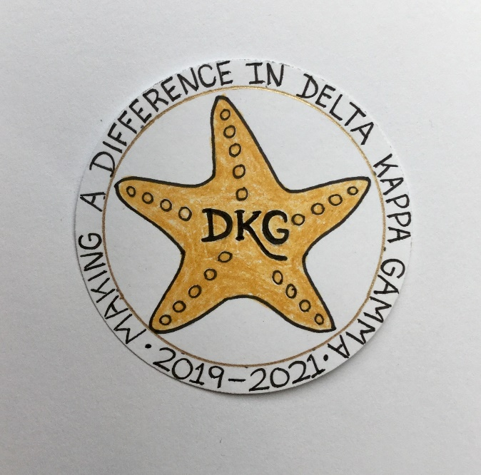
Alpha Delta Newsletter - - October, 2019
Illinois State Organization, ALPHA DELTA CHAPTER # 28 Cook County, Illinois
Mission: The Delta Kappa Gamma Society International promotes professional and personal growth of women educators and excellence in education.
Vision: Leading Women Educators Impacting Education Worldwide

Chapter Theme: Making a Difference
Chapter Focus: Sharing our Choices for Action

Dear Alpha Delta Chapter Members,

**Our meeting at Jedi’s Garden Restaurant on Saturday, September 28, 2019 was absolutely wonderful! Along with a delicious meal, we had State Organization and chapter committee news, the yearbook distribution, and a display of Creative Arts Retreat Projects. Members enjoyed the presentation by Michelle, Tamika and Salena from the Play Smart Literacy program. They interact with parents and their young children encouraging “Talk and Play” activities. Visit them at www.PlaySmartLiteracy.org. Volunteer opportunities are available. Check Amazon.com for their suggested book, The Gift of Words: How Do Children Learn To Talk? written by Tamalge Steele.

**A note to those who go on FACEBOOK - - - Our 2019-2021 Illinois State Organization President, Beverley Johns has encouraged us to LIKE the State Facebook page at: DKG-Illinois key women educators. Bev posts news about DKG and our Illinois chapters every day.

**Visitation with the State Ambassadors will not be required during this 2019-2021 biennium! Ambassadors will only be assigned to “needy” chapters. President Beverley wants to “Rebuild” them and not let them fail ! ! !

**The new Chapter Leaders for the 2020-2022 Biennium will have three (3) opportunities to attend training from our State Leaders. They may attend the Leadership Academy Collaborative Workshop one day before Convention on Friday, April 24, 2020 at the Marriott Airport St. Louis. The second date is on June 6, 2020 at Bradley University. The third training takes place at the IEA Office in Bloomington-Normal on July 16, 2020.

**If interested in conducting a workshop at State Convention, all proposals are due by December 15, 2019. Check the state website for information and forms.

**State Scholarship Applications and Special Study Stipends may be found on the state website and are due to Scholarships Chair Delores Jones by January 9, 2020.

**Our Chapter Yearbooks are lovely – Special THANKS to Luba Johnson! Have you noticed the 2 new pages – the Birthday List and the CCCC Chapter Achievement Awardees?

**Visit our Chapter Website. More members have been added to the Showcasing page. In response to a suggestion at the May, 2019 meeting, our wonderful Webmaster Kim has now included a book review section. Check out the “Literacy Corner” for reviews, colorful book covers and many great reading suggestions!

**Reminders and Upcoming Events – Please set your calendars:
- The DKG, Illinois, Legislative Seminar will be held at the Lincoln Library, The Public Library of Springfield, IL, 326 South 7th Street, Springfield, IL on Saturday, October 26, 2019. Cost: $36.00. Forms are on the State Website at www.deltakappagamma.org/IL/.

- Our next chapter meeting is Saturday, November 2, 2019 at Old St. Mary’s Church. Every member is invited to share an object or brief story and explain how it made a difference in her life. We will also have a Memorial Service for Carole J. Ireland.

- December 14, 2019 – Chapter Meeting – Colletti’s Restaurant, 11:30 A.M. Send completed forms of all candidates for membership to Chair Rosemary Smith ASAP.

- January 25, 2020 – Chapter Meeting – La Villa Banquets, 11:30 A.M.

- May 16, 2020 – Chapter Meeting – Prime Time Restaurant, 11:30 A.M.

- Saturday, March 7, 2020 11:30 A.M.
Cook County Coordinating Council Annual Awards Luncheon,
Wilmette Golf Club, 3900 Fairway Drive, Wilmette, IL 847-256-9777

- Friday-Sunday, April 24-26, 2020
Illinois State Organization Convention, Marriott Airport St. Louis, in St. Louis, MO

- Tuesday-Thursday, June 23-25, 2020
Creative Arts Retreat at Allerton Park, in Monticello, IL. Forms are available on the State Website. Registration is now OPEN.

- Tuesday-Saturday, July 7-11, 2020
DKG International Convention, Philadelphia, PA. Registration opens in January, 2020.

Let’s Make A Difference
Have you spoken lately to a chapter member?
Is there someone whom you have missed seeing at our meetings? Perhaps it was someone you sponsored or who sponsored you. Check and see if anyone needs a ride to a meeting. How nice it would be to receive a call from someone who cares!

Happy Birthday Greetings

October – Maria Garcia, Patricia Gaines, Ann Hennessy
November – Joanne Kiewicz, Brenda Harris, Peggy Jackson-Edwards

Many blessings and much good health to all,
Pat Gaines

