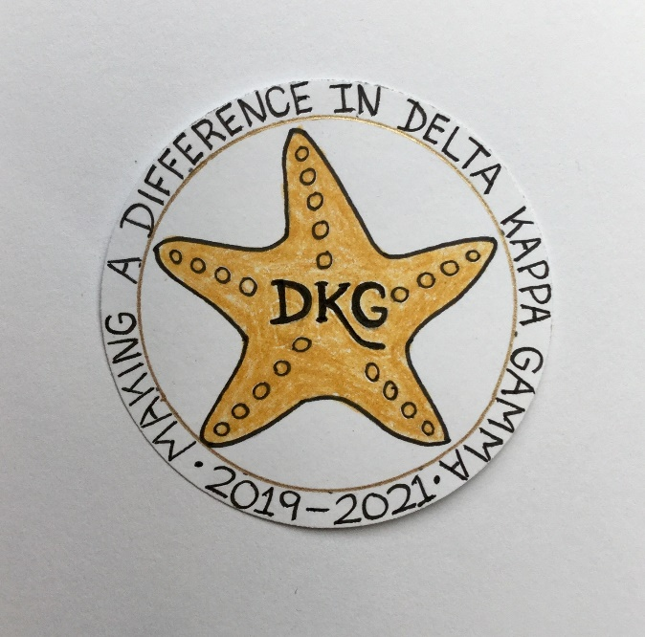
Alpha Delta Newsletter - - November, 2019
Illinois State Organization, ALPHA DELTA CHAPTER # 28 Cook County, Illinois
Mission: The Delta Kappa Gamma Society International promotes professional and personal growth of women educators and excellence in education.
Vision: Leading Women Educators Impacting Education Worldwide

Chapter Theme: Making a Difference
Chapter Focus: Sharing our Choices for Action

Dear Alpha Delta Chapter Members,

*We met at Old St. Mary’s Church on Saturday, November 2, 2019. Carole Ireland’s daughter, Heather and brother, Welby joined us for the White Rose Ceremony. Lovely tributes were shared. We also celebrated our 78th year with a listing of members, speakers and locations of meetings during the 1940’s. Joanne Kiewicz sent information from the Legislative Seminar she attended in Springfield. After chapter business, Panera Bread lunches, fruit, and birthday cupcakes were enjoyed. Members then shared an object or story that Made A Difference in their lives. Poignant stories were told of transitioning to a new home, the impact of nieces, nephews and grandchildren, benefits of Naturalization, facing and overcoming challenges, treasured family keepsakes, the joys of advocacy , and the camaraderie with 89 participants who learned how their donations to our State Project, Building Shallow Wells in Malawi, truly made a difference.

*Reminder to those who go on FACEBOOK - - - President Bev Johns, our 2019-2021 Illinois State Organization President, has encouraged us to LIKE the State Facebook page at: DKG-Illinois key women educators. Bev posts news about DKG and our Illinois chapters every day.

*Six (6) Chapter Leaders for the 2020-2022 Biennium will have three (3) opportunities to attend training from our State Leaders. The President, Treasurer, and Chairs of Membership, Finance, Educational Excellence and Communications & Marketing may attend the Leadership Academy Collaborative Workshop one day before Convention on Friday, April 24, 2020 at the Marriott Airport St. Louis. The second date is on June 6, 2020 at Bradley University. The third training takes place at the IEA Office in Bloomington-Normal on July 16, 2020.

*Plan to attend the Illinois State Organization Convention – Call the Marriott Airport St. Louis Hotel now for reservations – 314-423-9700 for April 24-26, 2020!!!

*If interested in conducting a workshop at State Convention, all proposals are due by December 15, 2019. Check the state website for information and forms.

*State Scholarship Applications and Special Study Stipends are on the state website and due to Scholarships Chair Delores Jones by January 9, 2020.

*Visit our Chapter Website. Check out the “Literacy Corner” to answer the BIG QUESTION. Where Will Your Reading Take You? LOOK for reviews, colorful book covers and many great reading suggestions!

*Consider inviting a key woman educator – or two. Send completed forms for all candidates for membership to Chair Rosemary Smith ASAP.

*Reminders and Upcoming Events – Please set your calendars:
- December 14, 2019 – Our next Chapter Meeting is at Colletti’s Restaurant, 11:30 A.M.
We will have “Zentangle Fun” as we create beautiful greeting cards with Cindy Roder.

- January 25, 2020 – Chapter Meeting – La Villa Banquets, 11:30 A.M. Dr. Roxanne Owens will share Learning Strategies to Teach About the Titanic.

- May 16, 2020 – Chapter Meeting – Prime Time Restaurant, 11:30 A.M. Induction of New Members; Installation of 2020-2022 Officers; “Reflections from Within” with
Donna Soukup

- Saturday, March 7, 2020 11:30 A.M.
Cook County Coordinating Council Annual Awards Luncheon,
Wilmette Golf Club, 3900 Fairway Drive, Wilmette, IL 847-256-9777

- Friday-Sunday, April 24-26, 2020
Illinois State Organization Convention, Marriott Airport St. Louis, in St. Louis, MO

- Tuesday-Thursday, June 23-25, 2020
Creative Arts Retreat at Allerton Park, in Monticello, IL. Forms are available on the State Website. Registration is now OPEN.

- Tuesday-Saturday, July 7-11, 2020
DKG International Convention, Philadelphia, PA. Registration opens in January, 2020.

** Let’s Make A Difference **
Have you spoken lately to a chapter member?
Is there someone whom you have missed seeing at our meetings? Perhaps it was someone you sponsored or who sponsored you. Check and see if anyone needs a ride to a meeting. How nice it would be to receive a call from someone who cares!

Happy Birthday Greetings

November – Joanne Kiewicz, Brenda Harris, Peggy Jackson-Edwards
December – Ellie Sotirova, Liane Troy, Beverly Bennett

Have a WONDERFUL Thanksgiving with many blessings and much good health to all.
Pat

