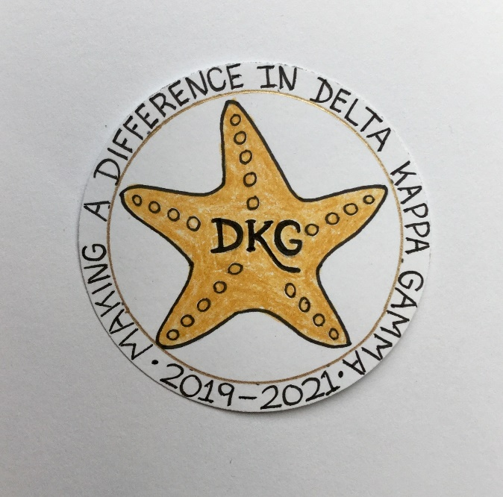
Alpha Delta Newsletter - - December, 2019
Illinois State Organization, ALPHA DELTA CHAPTER # 28 Cook County, Illinois
Mission: The Delta Kappa Gamma Society International promotes professional and personal growth of women educators and excellence in education.
Vision: Leading Women Educators Impacting Education Worldwide

Chapter Theme: Making a Difference
Chapter Focus: Sharing our Choices for Action

Dear Alpha Delta Chapter Members,

*We are looking forward to seeing many of you at our Holiday Meeting on December 14th at Colletti’s Restaurant. You won’t want to miss our own Cindy Roder, chapter Historian, who will help us create lovely greeting cards using Zentangle patterns. Bring a friend and join us for the business meeting, the announcement of our 2020-2022 Slate, and cute door prizes!

*Invite a key woman educator – or two – into membership in DKG. Contact Membership Chair Rosemary Smith or President Pat for forms. Send completed forms for all candidates for membership to Chair Rosemary Smith ASAP.

*We extend our congratulations to Dr. Debra LeBlanc, Immediate Past Illinois State Organization President. She is the nominee for Northeast Regional Director of the Delta Kappa Gamma Society International. This is quite an honor! We are very proud of our dedicated, hard-working, positive Debbie who continues to create opportunities to assist and encourage educators in their professional growth.

*Cook County Coordinating Council - - Do you have candidate suggestions for the following three (3) areas? Please send your recommendations to the assigned contact person by December 31, 2019. They will be forwarded to CCCC by the January 15th deadline. THANKS!
1) CCCC – Student Teacher or Intern – Dr. Patricia Mizerka
2) CCCC – Legislative Award – Joanne Kiewicz
3) CCCC – Chapter Achievement Award – Donna Soukup & President Pat

*President Beverley Johns, our Illinois State Organization President, has encouraged us to LIKE the State Facebook page at: DKG-Illinois key women educators. News about DKG and our Illinois chapters is posted by President Bev every day.

*Six (6) Chapter Leaders for the 2020-2022 Biennium have three (3) opportunities to attend training from our State Leaders. The President, Treasurer, and Chairs of Membership, Finance, Educational Excellence and Communications & Marketing may attend the Leadership Academy Collaborative Workshop on Friday, April 24, 2020 at the Marriott Airport St. Louis. The second date is on June 6, 2020 at Bradley University. The third training takes place at the IEA Office in Bloomington-Normal on July 16, 2020.

*If interested in conducting a workshop at State Convention, all proposals are due by December 15, 2019. State Scholarship Applications and Special Study Stipends are due to Scholarships Chair Delores Jones by January 9, 2020. Forms are on the state website.

*Webmaster Kimberly invites us all to visit the Chapter Website, including the “Literacy Corner.” LOOK for reviews and many great reading suggestions! HAPPY READING! New addition to her family, baby Bennett, is making brother Mason, Dad and Mom – very happy! Congratulations, Kimberly! (Your family pictures are beautiful!)

*Reminders and Upcoming Events – Please set your calendars:
- January 25, 2020 – Chapter Meeting – La Villa Banquets, 11:30 A.M. Dr. Roxanne Owens, Teacher Education Chair at DePaul University, will share Learning Strategies to Teach About the Titanic.

- May 16, 2020 – Chapter Meeting – Prime Time Restaurant, 11:30 A.M. Induction of New Members; Installation of 2020-2022 Officers. Donna Soukup, our 1st Vice-President and Nominations Chair will present “Reflections from Within.”

- Saturday, March 7, 2020 11:30 A.M.
Cook County Coordinating Council Annual Awards Luncheon,
Wilmette Golf Club, 3900 Fairway Drive, Wilmette, IL 847-256-9777

- Friday-Sunday, April 24-26, 2020
Illinois State Organization Convention, Marriott Airport St. Louis, in St. Louis, MO.
Call the Marriott Airport St. Louis Hotel now for reservations – 314-423-9700
for April 24-26, 2020! Our International Visitor will be DKG President Cathy Daugherty!

- Tuesday-Thursday, June 23-25, 2020
Creative Arts Retreat at Allerton Park, in Monticello, IL. Forms are available on the State Website. Registration is now OPEN.

- Tuesday-Saturday, July 7-11, 2020
DKG International Convention, Philadelphia, PA. Registration opens in January, 2020.

Have you spoken lately to a chapter member?
Is there someone whom you have missed seeing at our meetings? Check and see if anyone needs a ride to a meeting. How nice it would be to receive a call from someone who cares!

Happy Birthday Greetings
December – Ellie Sotirova, Liane Troy, Beverly Bennett
January – Ewa Shimasaki, Grace Tsuru, Kimberly Malinowski

