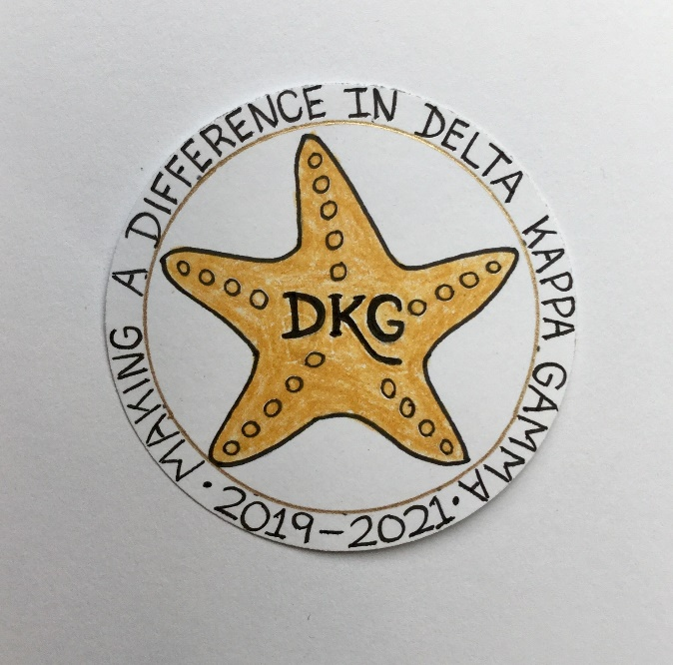
Alpha Delta Newsletter - - February, 2020
Illinois State Organization, ALPHA DELTA CHAPTER # 28 - Cook County
Mission: The Delta Kappa Gamma Society International promotes professional
and personal growth of women educators and excellence in education.
Vision: Leading Women Educators Impacting Education Worldwide

Chapter Theme: Making a Difference
Chapter Focus: Sharing our Choices for Action

Dear Alpha Delta Chapter Members,

*Our January Meeting was on the 25th at the beautiful La Villa Banquets. The 2020-2022 Slate was voted upon. Our Co-Presidents are Cindy Roder and Donna Soukup. First VP is Brenda Harris, 2nd VP is Christiane Jochimski, Recording Secretary is Mary Jane Riopelle and Luba Johnson is Corresponding Secretary. We congratulate our incoming officers who will be installed at our next chapter meeting on May 16, 2020. We elected Dr. Roxanne Owens to membership. She was our presenter and led a delightful interactive workshop, giving information about the Titanic. Facts were shared and rumors were debunked!

*We lost a very dear member, Diane Zmaczynski on January 15, 2020. She was inducted in 1971 and remained a dedicated, devoted DKG member for 49 years. Diane was treasurer for many years and Chapter President during the 1996-98 biennium. She was a member on the State Finance Committee and was State Finance Chairman in 1987-89. Diane served as State Registrar for several biennia and Secretary on the Foundation for Educational Studies Board. She will be greatly missed! During our December meeting, we selected and voted Diane as our 2020 CCCC Chapter Achievement Awardee. Her daughter will accept her certificate on March 7, 2020.

*Cook County Coordinating Council - - The registration form for the March 7th Annual Luncheon is attached. Make your lunch selections and be an “early bird” by returning it by February 12, 2020. After the 12th, the cost is higher. There will be speakers from the WINGS Program. They have issued a “Safe House Wish List” if anyone wishes to make donations to them, this list is also attached.

*More members have signed up and accepted the invitation from member Ann Collins to have a meeting/outing at her home in Union Pier, Michigan during the warmer weather. Her invitation letter is attached with this February Newsletter. PLEASE let me hear from EVERYONE and respond to President Pat – ASAP - with your date preferences for attendance. Let’s carpool and spend some relaxing / fun time with Ann.

*Have you joined the State Facebook page at: DKG-Illinois key women educators ? Our Illinois State Organization President Bev Johns has encouraged us to LIKE the State Facebook page where she posts news about DKG and our Illinois chapters every day.

*Four of our incoming Chapter Leaders for the 2020-2022 Biennium will attend the Leadership Academy Collaborative Workshop on Friday, April 24, 2020 at the Marriott Airport St. Louis during our State Convention. Two others will attend on June 6, 2020 at Bradley University.

*The chapter will have the White Rose Ceremony for Dr. Kyle Wade during our May, 2020 chapter meeting. The White Rose Ceremony for Diane Zmaczynski will be held during the September, 2020 chapter meeting. Also, on April 26, 2020 at the Illinois State Organization Convention, all three of our ladies - - Carole Ireland, Dr. Kyle Wade and Diane Zmaczynski - - will be honored with a rose placed in the vase during the Sunday morning Celebration of Life Ceremony.

*Have you been enjoying the reviews and wonderful reading suggestions posted by our Webmaster Kimberly in the “Literacy Corner” on our chapter website. HAPPY READING!

*For All Shoppers – DKG receives a small donation from Amazon when we shop through smile.amazon.com. 0.5% of your purchase will be donated to DKG Supporting Corporation which supports many of our DKG funds. To start your AmazonSmile account, go to dkg.org and click on About Us>How To Become A Member>Discounts. Then, select DKG Supporting Corporation as your charity. HAPPY SHOPPING!

*Reminders and Upcoming Events – Please set your calendars:
- May 16, 2020 – Chapter Meeting – Prime Time Restaurant, 11:30 A.M. Induction of New Member; Installation of 2020-2022 Officers; White Rose Ceremony for Dr. Kyle Wade.

- Saturday, March 7, 2020 11:15 A.M.
Cook County Coordinating Council Annual Awards Luncheon,
Wilmette Golf Club, 3900 Fairway Drive, Wilmette, IL 847-256-9777

- Friday-Sunday, April 24-26, 2020
Illinois State Organization Convention, Marriott Airport St. Louis, in St. Louis, MO.
Call the Marriott Airport St. Louis Hotel now for reservations – 314-423-9700
for April 24-26, 2020! Our International Visitor will be DKG President Cathy Daugherty!

- Tuesday-Thursday, June 23-25, 2020
Creative Arts Retreat at Allerton Park, in Monticello, IL. Forms are available on the State Website. Registration is OPEN.

- Tuesday-Saturday, July 7-11, 2020
DKG International Convention, Philadelphia, PA. Registration opens in January, 2020.

- Wednesday, August 5, 2020
Celebrating Women Educators, at Sleepy Creek Vineyard’s Dragonfly in Fairmount, IL – Enjoy shopping and sipping wine followed by dinner and a program – Join Illinois State Organization President Beverley Johns -- Celebrating Women Educators - $30.

Have you spoken lately to a chapter member?
Is there someone whom you have missed seeing at our meetings? Check and see if anyone needs a ride to a meeting. How nice it would be to receive a call from someone who cares!

Happy Birthday Greetings

February – Roberta Sue Metz, Christiane Jochimski, Luba Johnson, Jean Collins, Ann Collins

Invitation from Elizabeth “Ann” Collins

*We received an invitation from member Ann Collins to have a meeting/outing at her home in Union Pier, Michigan during the warmer weather. Ann has sent a few emails with “links” to describe the lovely area – Harbor Country, places to visit, and things to see and do. I will forward them to you, but I will also share a bit of what I learned in this note. We can ride together, as carpooling is a great option. Ann also sent information about the Amtrak train from Union Station. She can meet the train and pick us up.

We have 12 open dates in June, 2020. They are June 3, 4, 5, 7, 9, 10, 11, 12, 13, 16, 17, 18. There is one date in July and that is July 1, 2020. PLEASE respond with ALL of the preferred dates that you would be able to join us and spend some relaxing / fun time with Ann. I will then collate and determine our best option. We hope many of you will be available for this special outing!

Ann has a couple of acres, a swimming pool, outdoor games, croquet, golf carts . . . We can get there around 11:00 (or so) and have snacks and lunch. This could be a nice, casual, informal time for discussions, planning, relaxing, game-playing, etc. With a modest $15 from each of us, Ann will provide the sustenance.

From my note taking: “Harbor Country” has 8 Great Towns and 1 Great Lake! From south to north there are 7 lakeshore towns (Michiana, Grand Beach, New Buffalo, Union Pier, Lakeside, Herbert and Sawyer). There is one slightly inland town (Three Oaks) . . . UNION PIER is 4 miles north of New Buffalo and a major destination for family vacations with a wide variety of lodging choices. It has fine dining and casual eateries. Their corner store and ice cream parlor compliment the art galleries and other businesses located along Red Arrow Highway . . . NEW BUFFALO is known as the “Gateway to Michigan” and is the cornerstone to Harbor Country. The largest public beach in the area is located at the base of the city’s downtown district. New Buffalo’s harbor boasts the largest number of slips on the sunset coast (more than 1,100). They have a public boat launch and transient marina.

Things to do in Harbor Country: Art Galleries, Antique Shops, “Gift” Shops, Wineries, Craft Breweries, Distilleries, Museums, Farmer’s Markets, Family Farms, Concerts at Acorn Theater or Silver Creek Event Center Theater, Four Winds Casino, Tours, Golf, Swimming . . .

***Take the Amtrak Bluewater or Amtrak Wolverine, both from Union Station, 225 S. Canal Street, Chicago --- To New Buffalo, 226 N. Whittaker Street. THEN, Ann can pick us up! COST: from $9.50 to an average of $13 or #15. --- 1st train at 7:00 am. Last train at 5:00 pm. --- Time is 1 hour and 15 minutes or 1 hour and 8 minutes.

***For Carpooling – use Mapquest or your GPS . . .

Please email or snail mail your response to President Pat by January 31, 2020. ASAP - - Thank you.

** ** ** ** ** ** ** ** ** ** **

Name: _____________________________________________________

I can attend on any of the following dates: _________________________________________________

____________________________________________________________________________________

I wish to ride with / carpool with others: Yes_____________ No________________

I will drive and can pick up others: Yes _______________

THE DELTA KAPPA GAMMMA SOCIETY INTERNATIONAL ILLINOIS STATE ORGANIZATION COOK COUNTY COORDINATING COUNCIL

2020 CCCC AWARDS
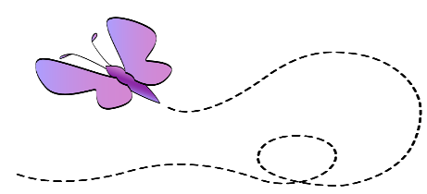

“Wings to Success”

- DATE: Saturday, March 7, 2020
- LOCATION: Wilmette Golf Club, 3900 Fairway Drive, Wilmette, IL 60091, 847.256.9777
- COST: Early Birds ~ $35 After February 12, 2020 ~ $40.00
- TIME: Executive Board Mtg: @ 10:45 Fellowship @ 11:15 Luncheon @ 11:45 Program @ 1:15

Cash Bar will be available
- - - - - - - - - - - - - - - - - - - - - - - - - - - - - - - - - - - - - - - - - -
Return reservations to Laura Sorce, 707 S. Ada, Chicago, IL 60607
Make check(s) payable to Cook County Coordinating Council
Reservations must be postmarked on or before February 12, 2020 for early bird consideration (no exceptions)

Please give complete information for each person for whom payment is enclosed
Please print clearly.+
Name______________________ Phone_______________ E-mail______________________
Street______________________ City_________________ Zip_________________________
Chapter Name________________________ Meal Choice: ________Vegetable Lasagna
Status: ____ Member ____ Chicken Marsala with Noodles
____ Guest ____ Lemon Pepper Salmon with Dill Sauce
____ Speaker or Nominee for ______________ Award
(Chapter, Student Teacher, Legislator)

Name______________________ Phone_______________ E-mail______________________
Street______________________ City_________________ Zip_________________________
Chapter Name________________________ Meal Choice: _______ Vegetable Lasagna
Status: ____ Member ____ Chicken Marsala with Noodles
____ Guest ____ Lemon Pepper Salmon with Dill Sauce
____ Speaker or Nominee for ______________ Award
(Chapter, Student Teacher, Legislator)

Name______________________ Phone_______________ E-mail______________________
Street______________________ City_________________ Zip_________________________
Chapter Name________________________ Meal Choice: ________Vegetable Lasagna
Status: ____ Member ____ Chicken Marsala with Noodles ____ Guest ____ Lemon Pepper Salmon with Dill Sauce
____ Speaker or Nominee for ______________ Award
(Chapter, Student Teacher, Legislator)

- All meals are served with a garden salad with Soy Buttermilk and balsamic dressing, twice baked potatoes, green beans with Pesto & roasted tomato and bread sticks. Dessert includes a trio mix of key lime bar, mini black bottom cupcake and ganache tartelette. Choice of beverages include: coffee, tea (hot or cold), lemonade and soft drink.
- If there are additional questions, please leave a phone message at. 312-371-5864, lesorce@gmail.com
If more space is needed, please recreate the format on an additional sheet of paper.

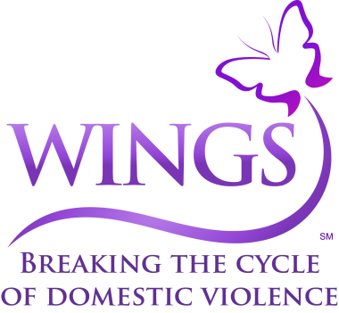 Safe House Wish List
Women’s Body Lotion/Wash | Day Planners | Cantu or Suave Professionals Shampoo/Conditioner | Disposable Coffee Cups – 12oz or larger
Ampro Hair Gel | Oil Sheen Spray for Hair | Hair Brushes/Wide Tooth Combs | Women’s/Men’s Deodorant
Potty Seats | Hair Mousse/Hairspray | Adult/Child Allergy Medicine | Men’s/Women’s Robes – Small to 3X – New or Used
Baby Wipes | Paper Towels/Toilet Paper | Scotch Tape Refills For Tape Dispensers | Baby (Sensitive Skin) Shampoo/Wash
Earbuds | Washcloths | Pull-Ups – Small up to 65 lbs | Pull-Ups – Large up to 120 lbs
Pull-Ups – Sizes 3-4 and 4-5 | Diapers – Size 4, 5 and 6 | Bath/Hand Towels | AA & AAA Batteries
Hand Soap/Hand Sanitizer | New Breast Pumps | Journals | Laundry Detergent/ Fabric Softener
Contact Tabitha Nilson – In-kind Program Donations Supervisor
tnilson@wingsprogram.com – 847-519-7820 x 390

