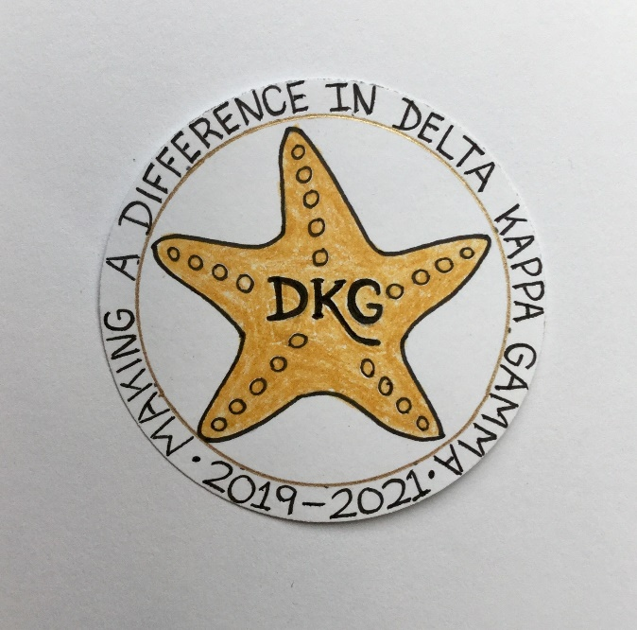
Alpha Delta Newsletter - - March, 2020
Illinois State Organization, ALPHA DELTA CHAPTER # 28 Cook County, Illinois
Mission: The Delta Kappa Gamma Society International promotes professional and personal growth of women educators and excellence in education.
Vision: Leading Women Educators Impacting Education Worldwide

Chapter Theme: Making a Difference
Chapter Focus: Sharing our Choices for Action

Dear Alpha Delta Chapter Members,

*Cook County Coordinating Council - - We are looking forward to seeing you next week at the March 7, 2020 Annual Luncheon. There will be speakers from the WINGS Program. Remember to bring your donations from their “Safe House Wish List” which was included with the February newsletter. Also, we are again encouraged to bring school items/supplies for student teachers. We selected and voted at the December meeting for Diane Zmaczynski to be our 2020 CCCC Chapter Achievement Awardee. Her daughter and son will attend and receive her certificate. Come out and enjoy the fellowship, a delicious lunch and you may even be one of the prize winners!

*Our very next event is the Illinois State Organization Convention on Friday through Sunday, April 24-26, 2020 at the Marriott Airport St. Louis, in St. Louis, MO. Our International Visitor will be DKG International President Cathy Daugherty! Everyone is invited to bring and wear a “vintage hat” at the Friday evening session! We will be voting on motions on Saturday at the General Business Meeting – so bring your Spring Newscaster. You will have your choice of Workshops and Ten Minute Take-A-Way sessions. Members will be honored during the Membership Luncheon. The Saturday evening Presidents’ Banquet is always exceptional with a featured speaker. Members, Carole Ireland, Dr. Kyle Wade, and Diane Zmaczynski, will be celebrated at the Sunday morning Memorial Service and awards will be given to students during the Sunday Breakfast. Hope YOU will be participating in this informative, annual event!
*** This year, the theme for the Art Mart is “Under the Sea.” To raise funds during Convention, for the M. Josephine O’Neil Arts Award, we are asked to DONATE handmade items. If YOU have anything to DONATE, please notify President Pat ASAP. ***

*Four of our incoming Chapter Leaders for the 2020-2022 Biennium will be attending the Leadership Academy Collaborative Workshop on Friday, April 24, 2020 at the Marriott Airport St. Louis during our State Convention. Two others will attend on June 6, 2020 at Bradley University.

*Some members have accepted the invitation from member Ann Collins and signed up to attend a meeting/outing at her home in Union Pier, Michigan during the warmer weather. Her invitation letter was attached with the February Newsletter. We can travel by train, drive, or carpool to spend some relaxing / fun time with Ann. I need to hear from EVERYONE ASAP. Please call or email me with your date preferences for attendance. We can then finalize a date.

*Have you joined the State Facebook page at: DKG-Illinois key women educators? Our Illinois State Organization President Bev Johns has encouraged us to LIKE the State Facebook page where she posts news about DKG and our Illinois chapters every day.

*We will have the White Rose Ceremony for Dr. Kyle Wade during our May chapter meeting. The Ceremony for Diane Zmaczynski will be held during the September Chapter Meeting.

*Webmaster Kimberly has developed and included the “Literacy Corner” on our chapter website. Have you read the reviews and selected a few books for your reading pleasure???

*For All Shoppers – DKG receives a small donation from Amazon when we shop through smile.amazon.com. 0.5% of your purchase will be donated to DKG Supporting Corporation which supports many of our DKG funds. To start your AmazonSmile account, go to dkg.org and click on About Us>How To Become A Member>Discounts. Then, select DKG Supporting Corporation as your charity. HAPPY SHOPPING!

*Reminders and Upcoming Events – Please set your calendars:
- May 16, 2020 – Chapter Meeting – Prime Time Restaurant, 11:30 A.M. Induction of New Members; Installation of 2020-2022 Officers; White Rose Ceremony for Dr. Kyle Wade.

- Saturday, March 7, 2020 11:30 A.M.
Cook County Coordinating Council Annual Awards Luncheon,
Wilmette Golf Club, 3900 Fairway Drive, Wilmette, IL 847-256-9777

- Friday-Sunday, April 24-26, 2020
Illinois State Organization Convention, Marriott Airport St. Louis, in St. Louis, MO.
Call the Marriott Airport St. Louis Hotel now for reservations – 314-423-9700
for April 24-26, 2020! Come and visit with DKG President Cathy Daugherty!

- Tuesday-Thursday, June 23-25, 2020
Creative Arts Retreat at Allerton Park, in Monticello, IL. Forms are available on the State Website. Registration is OPEN.

- Tuesday-Saturday, July 7-11, 2020
DKG International Convention, Philadelphia, PA. Registration opened in January, 2020.

Have you spoken lately to a chapter member?
Is there someone whom you have missed seeing at our meetings? Please check and see if anyone needs a ride to a meeting. How nice it is to receive a call from someone who cares!

Happy Birthday Greetings
April – Denise Gamble, Samantha Denson, Rita Dawkins

Sincere well wishes to all!
Patricia Gaines, President

