Alpha Delta Newsletter - - March & April 2022 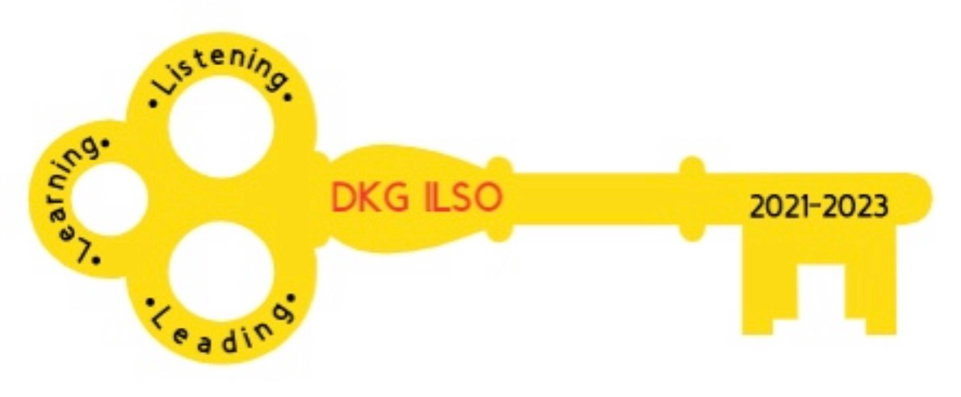
Illinois State Organization, ALPHA DELTA CHAPTER # 28 Cook County, Illinois
Mission: The Delta Kappa Gamma Society International promotes professional and personal growth of women educators and excellence in education.
Vision: Leading Women Educators Impacting Education Worldwide

Dear Alpha Delta Chapter Members,
Happy Birthday Greetings

April -01 Denise Gamble 26 Samantha Denson 28 Rita Dawkins

Listening, Learning and Leading

There is a new feature on the DKG-Illinois Key Women FaceBook page. Bev Johns will be sharing “Bobbie’s ( Finn) Book Choices.” Bobbie was past State Literacy Chairperson and is a member of Alpha Theta. She recommends books by author Ronald Balson who is a Chicago Trial Attorney. His books are suspenseful with all kinds of twists and turns. His books will not disappoint you.
Once We Were Brothers
Saving Sophie
Girl From Berlin
Karolina’s Twins
The Trust

CCCC Awards Meeting Saturday March 5, 2022 at 11:00 a.m.

The DKG Emergency Fund is the designated charity this year. CCCC will donate $500.00 to this fund. The Luba Johnson Outstanding Student Teacher Awardee recipients will each receive a $100.00 gift card .

Alpha Delta ChapterElected Officers – 2022-2024
Co-Presidents
Dr. Patricia Mizerka * * * Cindy Roder
1st Vice-President
Gretchen Alexander
2nd Vice-President
Christiane Jochimski
Recording Secretary
Dr. Roxanne Owens
Corresponding Secretary
Joanne Kiewicz

Below is a draft of dates for our joint Zoom meetings:

MONTH | DAY | TIME | KAPPA | ALPHA DELTA | ETA | TOPIC
MAR | 5 | 11:00AM |  | X |  | CCCC
MAR | ?? | ?? | X |  |  | Chair Yoga
MAY | 7 | 10:00 AM |  | X |  | Diversity & Equity
MAY |  |  | X |  |  | CTPF Update
JUNE | 11 |  |  | X |  | EXECUTIVE BOARD

*Check Out DKG ILSO Resources*

https://youtu.be/zE1Kr27Wnp8 Click on this link to see a wonderful YouTube video of our history in Delta Kappa Gamma and the vision of founder, Annie Webb Blanton, shared by Becky Sadowski.

https://www.youtube.com/watch?v=yT7cgJLbObw Enjoy the revised link of the DKG rap video.

Zoom sessions YouTube Channel
nuchapterdkg@weebly.com Delta Kappa Gamma, Illinois, key women educators

Women in the Arts Facebook DKG Facebook
DKG-ILSOWIACAR DKG Illinois key women educators

* Very Important Information Regarding Contact Information*

*Check your contact information with the following persons: Lynne White, Rosemary Smith and Kim Malinowski. It is important for all contact information to be current.*

◆ Changes to emails and addresses should be sent to Dr. Kammie Richter, Editor, dkgilso.editor@gmail.com immediately so the members will continue to receive The Newscaster.
◆ Changes to emails and addresses should also be sent to our State Treasurer, Vicki
Smith, vlsteach@yahoo.com
◆ Changes to emails and addresses should be changed on the international website at dkg.org. You will need your DKG member number to log in. Your member number can be found in your yearbook.

If you need to update any information such as a new phone number, address or removing your email address at the state level please do the following:
- Go on State Connect after you log in and go to the Dues Portal.
- Click on your chapter name and then find the column that says Members.
- Click on Manage under that column.
- Find your name and click Edit on the far right.
- After making the changes, save your changes.

Alpha Delta Chapter Website

*We hope you have visited the chapter website at www.alphadelta-il.weebly.com and we encourage you to tell your friends all about us!

*For All Shoppers – DKG receives a small donation from Amazon when we shop through smile.amazon.com. 0.5% of your purchase will be donated to DKG Supporting Corporation which supports many of our DKG funds. To start your AmazonSmile account, go to dkg.org and click on About Us>How To Become A Member>Discounts. Then, select DKG Supporting Corporation as your charity. HAPPY SHOPPING!

Cindy Roder and Donna Soukup, Co- Presidents

