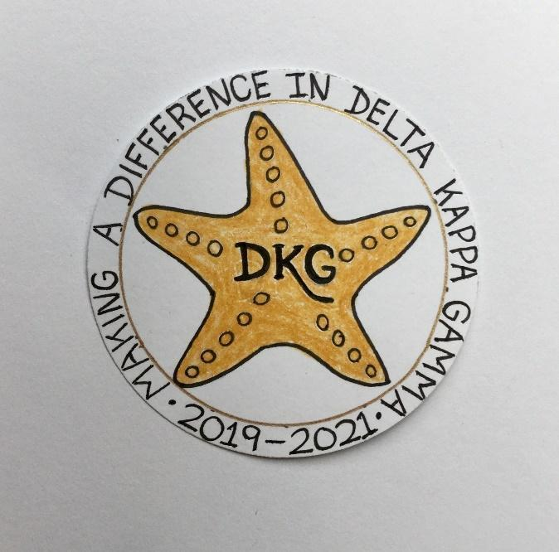
Alpha Delta Newsletter - - January & February, 2021
Illinois State Organization, ALPHA DELTA CHAPTER # 28 Cook County, Illinois
Mission: The Delta Kappa Gamma Society International promotes professional and personal growth of women educators and excellence in education.
Vision: Leading Women Educators Impacting Education Worldwide

Chapter Theme: Sharing our choices for action
Chapter Focus: Making a regional and global difference

Dear Alpha Delta Chapter Members,

Happy Birthday Greetings

January- 6 Ewa Shimasaki, 25 Grace Tsuru
30 Kim Malinowski
February – 08 Chris Jochimski, 12 L. Jean Collins,
20 Elizabeth Ann Collins

The dates for our Zoom meetings are as follows:

-Saturday, January 23, 2021 at 10:00 a.m. Chapter Meeting. Our program will be a powerpoint Necrology for Marie Feltus, Roberta Sue Metz, and Dr. Kyle Wade

-Saturday, March 6, 2021 CCCC Wilmette Country Club via Zoom

-Saturday, May 8, 2021 at 10:00 a.m. Our program will be a powerpoint Necrology for Diane Zmaczynski and Luba Johnson.

Deadlines
Five important deadlines are coming up. You can find all forms on our website at:
www.deltakappagamma.org/IL

January 1, 2021—letter of intent to apply for the M. Josephine O’Neil Award due with full application due by February 1, 2021—find forms by going to the committee page and clicking on Women in the Arts.
January 9, 2021—Deadline for Scholarships and Stipends Applications to Delores Jones—find forms by going to committee page and clicking on Scholarships
February 1, 2021—Deadline for Legislative Certificates of Appreciation to Janet Kilgus—find forms by going to committee page and clicking on Legislation
February 1, 2021—Deadline for Grant in Aid—find forms by going on committee page and clicking on Educational Excellence
February 1, 2021—Deadline for the Achievement Award to Joan Funk—find forms by going on committee page and clicking on Achievement Award

Contest for Participation in Our Zoom Workshops
We are having a contest to see which chapters have the most members attending our zoom workshops during the month of January and February. It will be calculated on a percentage basis and the top chapters will be recognized at the convention. So disseminate the information about our statewide zooms and encourage your chapter members to participate. January and February will be tough months for many members because of the weather combined with the coronavirus so it will be important to stay connected with our members.
Plus we have a great lineup of sessions coming up from Glamour on Zoom to Zentangle to Plant Based Diets to Writing to Reading Strategies, and the list goes on. There is something for everybody. For those of you who live in areas of the state where there is no internet, you can call in for the Zoom and while you can’t see it, you can at least hear it.

On our last zoom chapter meeting Brenda Harris, Dr. Barbara Martin and Bev Johns each won a $5.00 Dunkin Doughnut gift card.

Convention, 2021
The big news flash is that the State Planning Committee took action to move our convention for 2021 to a virtual one using the Zoom platform. We will be spreading the program out over a course of nine days. All of you have received your newscaster and know how we are planning to construct the conference. It will be a great time with opportunities to network with people from all over the state. Our International Society Representative will be Margarita Hanschmidt who serves as the European Regional Member. She will address everyone on Saturday during the 8 a.m.-11 a.m. business meeting and will do a roundtable on Friday morning at 10:30 a.m.-11:30 a.m. on “If I Really Knew You. The Cultural Iceberg.” On Saturday from 2 p.m.-3 p.m. she will do a roundtable on: “How to Have a Positive Mindset During Difficult Times.” Watch on facebook—DKG—Illinois key women educators- as more details are unveiled for the convention.

Chapter Connect
From our December 2020 Chapter Checkup- It is critical that you get your chapter members to update their profile on Chapter Connect on the DKG international website. We have discovered that International’s database has omitted some long time members from the list and luckily we were able to catch that in some cases, but there remain issues and we need you to ask your members to connect on the DKG International site. I have created a YouTube Video on how to do that and you can find it on our YouTube Channel at Delta Kappa Gamma, Illinois, key women educators.

We are still collecting recipes for our DKG Cookbook. It will be available this spring both in physical form and a printable document! Send your favorite“Sheltering in Place...” or“Making the Best of...”recipes to LaVonne Cheney, lavonnec45@gmail.com.

*Illinois Resources

Zoom sessions
nuchapterdkg@weebly.com

DKG Facebook
DKG-Illinois key women educators

Women in the Arts Facebook
DKG-ILSOWIACAR

YouTube Channel
Delta Kappa Gamma, Illinois, key women educators

January Challenge: Literacy
Spend 30-60 minutes each day reading or listening to an audio book.
Contact President Bev to sign up at pres.lambda.il.state@gmail.com

February Reducing Screen Time Challenge:
Set a time each day to move away from your computer, iPad or phone and do something for someone else whether it be a relative, a friend, or a neighbor.

*We hope you have visited the chapter website at www.alphadelta-il.weebly.com and we encourage you to tell your friends all about us! Please contact Pat Gaines so that she can write up a Showcasing Our Member profile on you if you are not showcased on our chapter website yet.

*For All Shoppers – DKG receives a small donation from Amazon when we shop through smile.amazon.com. 0.5% of your purchase will be donated to DKG Supporting Corporation which supports many of our DKG funds. To start your AmazonSmile account, go to dkg.org and click on About Us>How To Become A Member>Discounts. Then, select DKG Supporting Corporation as your charity. HAPPY SHOPPING!

Do you have unused gift cards to Walmart, Sam’s Club or Target to spare? If so, send them to Hugs for Our Soldiers (HugsForOurSoldiers.org)! The non-profit organization will use them to buy items for the care packages they ship to troops deployed overseas. Mail cards to P.O. Box 532, Vonore, TN 37885

“There are far greater things ahead than any we leave behind” -C.S. Lewis

We hope everyone continues using healthy practices to stay safe and well.
Wishing good health and safety to you and your family!
Cindy Roder and Donna Soukup, Co- Presidents

