Alpha Delta Newsletter - - January & February 2022 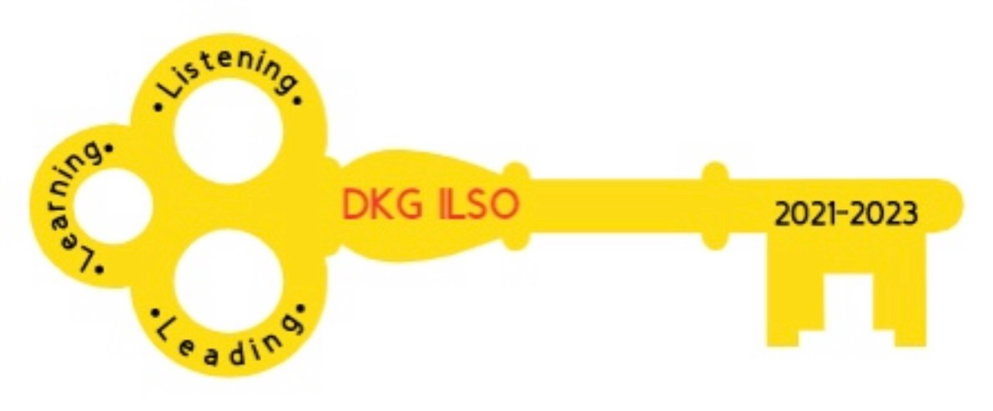
Illinois State Organization, ALPHA DELTA CHAPTER # 28 Cook County, Illinois
Mission: The Delta Kappa Gamma Society International promotes professional and personal growth of women educators and excellence in education.
Vision: Leading Women Educators Impacting Education Worldwide

Dear Alpha Delta Chapter Members,
Happy Birthday Greetings

January- 06 Ewa Shimasaki 25 Grace Tsuru 30 Kim Malinowski

February-08 Christiane Jochimski 12 L. Jean Collins 20 Elizabeth Ann Collins

Listening, Learning and Leading

* Register your vaccination card with the State of Illinois link*
https://dph.illinois.gov/resource-center/news/2021/december/illinois-vax-verify-system-now-offers-smart--health-card-vaccina.html

Chicago Public Schools Student Science Fair, Inc.
Our chapter has been donating to the Chicago Public Schools Science Fair, Inc. This year it will be held March 17-19, 2022 at IIT. If you would like to make an individual contribution towards the operating expenses, general scholarship or memorial scholarship in memory of Luba Johnson: Make your check payable to CPS Student Science Fair, Inc. and indicate in the check memo which fund you are contributing towards.

You will receive an acknowledgement letter as proof of your tax-deductible contribution.
You can send a donation to:
Rita S. Nelson
CPS Student Science Fair, Inc.
P.O. Box 803945
Chicago, Il. 60680-3945
CCCC Chapter Achievement Award

Ewa Shimasaki is receiving our Chapter Achievement Award for the upcoming CCCC Zoom program on March 5, 2022.
To support rainforest preservation actions via donation please visit rainforesttrust.org

Chapter Chairs
Send your written report to Pat Mizerka, Cindy Roder and Donna Soukup by January 14, 2022. (This will assist in setting our January agenda)

Alpha Delta Chapter

Please notify Chair Patricia Gaines by January 14, 2022 by email hndagpa19@comcast.net or by phone text or calling 773-266-7638 to vote for the 2022-2024 officers. Voting results will be announced at our January Zoom meeting
.
Nominations Slate of Elected Officers – 2022-2024

Co-Presidents
Dr. Patricia Mizerka * * * Cindy Roder

1st Vice-President
Gretchen Alexander

2nd Vice-President
Christiane Jochimski

Recording Secretary
Dr. Roxanne Owens

Corresponding Secretary
Joanne Kiewicz

Chapter Program, Saturday, January 22, 2021 at 10:30 a.m. (Revised Time)

We will continue celebrating our chapter’s 80th anniversary with a trip down memory lane brought to you by our very talented member Kim Malinowski. Donna and Cindy will provide time for members to share who sponsored them into the chapter and share a favorite memory.

Members and guests present will be entered into a $5.00 Dunkin Donuts e- gift card drawing. We will select 3 winners.

Below is a draft of dates for our joint Zoom meetings:

MONTH | DAY | TIME | KAPPA | ALPHA DELTA | ETA | TOPIC
JAN | 18 | 7:00 PM | X |  |  | Scams/Sheriff Aimee
JAN | 22 | 10:30 AM |  | X |  | 80 years of Alpha Delta
FEB | 7 | 7:00 PM |  |  | X | Zentangle/Pam
MAR | 5 |  |  | X |  | CCCC
MAR | ?? | ?? | X |  |  | Chair Yoga
MAY | 7 | 10:00 AM |  | X |  | Diversity & Equity
MAY |  |  | X |  |  | CTPF Update
JUNE | 11 |  |  | X |  | EXECUTIVE BOARD

*Check Out DKG ILSO Resources*

Zoom sessions YouTube Channel
nuchapterdkg@weebly.com Delta Kappa Gamma, Illinois, key women educators

Women in the Arts Facebook DKG Facebook
DKG-ILSOWIACAR DKG Illinois key women educators

* Very Important Information Regarding Contact Information*

*Check your contact information with the following persons: Lynne White, Rosemary Smith and Kim Malinowski. It is important for all contact information to be current.*

◆ Changes to emails and addresses should be sent to Dr. Kammie Richter, Editor, dkgilso.editor@gmail.com immediately so the members will continue to receive The Newscaster.
◆ Changes to emails and addresses should also be sent to our State Treasurer, Vicki
Smith, vlsteach@yahoo.com
◆ Changes to emails and addresses should be changed on the international website at dkg.org. You will need your DKG member number to log in. Your member number can be found in your yearbook.

Alpha Delta Chapter Website

*We hope you have visited the chapter website at www.alphadelta-il.weebly.com and we encourage you to tell your friends all about us!

*For All Shoppers – DKG receives a small donation from Amazon when we shop through smile.amazon.com. 0.5% of your purchase will be donated to DKG Supporting Corporation which supports many of our DKG funds. To start your AmazonSmile account, go to dkg.org and click on About Us>How To Become A Member>Discounts. Then, select DKG Supporting Corporation as your charity. HAPPY SHOPPING!

Do you have unused gift cards to Walmart, Sam’s Club or Target to spare? If so, send them to Hugs for Our Soldiers (HugsForOurSoldiers.org)! The non-profit organization will use them to buy items for the care packages they ship to troops deployed overseas. Mail cards to P.O. Box 532, Vonore, TN 37885

“There are far greater things ahead than any we leave behind” -C.S. Lewis
We hope everyone continues using healthy practices to stay safe and well.
Wishing good health and safety to you and your family!
Cindy Roder and Donna Soukup, Co- Presidents

