Alpha Delta Newsletter - - July & August, 2021
Illinois State Organization, ALPHA DELTA CHAPTER # 28 Cook County, Illinois
Mission: The Delta Kappa Gamma Society International promotes professional and personal growth of women educators and excellence in education.
Vision: Leading Women Educators Impacting Education Worldwide

Below is the new logo for our new State President Joan Rog.
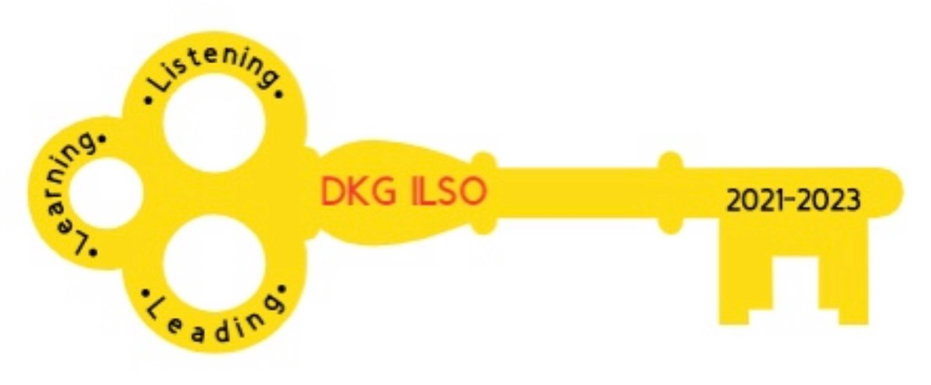
Please send ideas for us to use for our chapter theme and focus to go with the above logo. Kim will be updating our yearbook very soon. If you have any changes please send them to cindy.roder@gmail.com, dmsoukup@sbcglobal.net and kamalinowski@gmail.com.

Dear Alpha Delta Chapter Members,
Happy Birthday Greetings

July- 07 Nancy Mayer 23 Brenda Duncan 24 Cindy Roder

August-10 Ruth Ortigoza 16 Dorothy (Judy) Flynn 20 Angela White

-Saturday, July 10, 2021 at 10:30 a.m. our finance committee will meet in person.

-Wednesday, August 4, 2021 our Executive Board will be meeting on zoom. The agenda and notice to the Board members will be sent out closer to August 4, 2021.

The dates for our Zoom meetings are as follows:

-Saturday, October 2, 2021 10:00 on zoom

-Saturday, November 13, 2021 10:00 on zoom

-Saturday, December 4, 2021 10:00 on zoom.

-Saturday, January 22, 2022 10:00 on zoom.

-Saturday, March 5, 2022 CCCC

-Saturday, May, 7, 2022 10:00 on zoom.

-Saturday, Jene 11, 2022 Executive Board Meeting

Our programs will be listed in the chapter yearbook.

Permission to Post
Please take the time to fill out our “permission to post” form online to indicate if we are able to post your name and photo in DKG.ILSO publications. If you do not have access to a computer or smartphone to fill this out, please call Cindy (773-398-2762). The link to the permission to post form is below:

https://docs.google.com/forms/d/e/1FAIpQLSduOZwXH0K_DzLNi3LadkrDHVPY9sEdayYDY2BGPDuDMNuKFg/viewform?usp=sf_link

Chapter Connect
From our December 2020 Chapter Checkup- It is critical that you get your chapter members to update their profile on Chapter Connect on the DKG international website. We have discovered that International’s database has omitted some long time members from the list and luckily we were able to catch that in some cases, but there remain issues and we need you to ask your members to connect on the DKG International site. Bev has created a YouTube Video on how to do that and you can find it on our YouTube Channel at Delta Kappa Gamma, Illinois, key women educators.

Tasty Tip
Rinse any color grapes. Take them off the stem. While the grapes are still wet, roll them in sugar free jello. Any flavor works. Chill in the freezer. Enjoy

*Illinois Resources

Zoom sessions
nuchapterdkg@weebly.com

DKG Facebook
DKG-Illinois key women educators

Women in the Arts Facebook
DKG-ILSOWIACAR

YouTube Channel
Delta Kappa Gamma, Illinois, key women educators

*We hope you have visited the chapter website at www.alphadelta-il.weebly.com and we encourage you to tell your friends all about us!

*For All Shoppers – DKG receives a small donation from Amazon when we shop through smile.amazon.com. 0.5% of your purchase will be donated to DKG Supporting Corporation which supports many of our DKG funds. To start your AmazonSmile account, go to dkg.org and click on About Us>How To Become A Member>Discounts. Then, select DKG Supporting Corporation as your charity. HAPPY SHOPPING!

Do you have unused gift cards to Walmart, Sam’s Club or Target to spare? If so, send them to Hugs for Our Soldiers (HugsForOurSoldiers.org)! The non-profit organization will use them to buy items for the care packages they ship to troops deployed overseas. Mail cards to P.O. Box 532, Vonore, TN 37885

“There are far greater things ahead than any we leave behind” -C.S. Lewis
We hope everyone continues using healthy practices to stay safe and well.
Wishing good health and safety to you and your family!
Cindy Roder and Donna Soukup, Co- Presidents

