Alpha Delta Newsletter - - May & June 2022 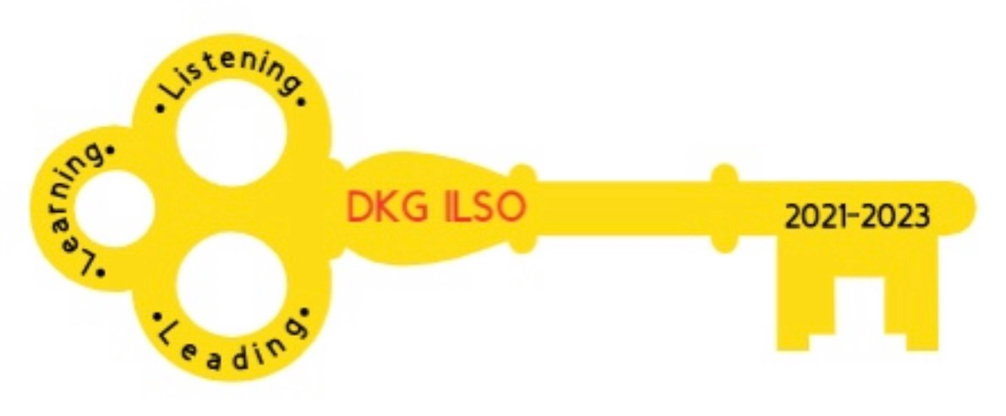
Illinois State Organization, ALPHA DELTA CHAPTER #28 Cook County, Illinois
Mission: The Delta Kappa Gamma Society International promotes professional and personal growth of women educators and excellence in education.
Vision: Leading Women Educators Impacting Education Worldwide

Dear Alpha Delta Sisters,
Cindy and I have thoroughly enjoyed our co-presidency this biennium, 2020-2022. Each of you made a difference by Listening, Learning and Leading by participating in various programs that DKG-ILSO had to offer.
You made a difference by contributing to Schools for Africa and the Malawi Wells project. During the past two years we supported five wells making it possible to provide safe drinking water to five villages in Malawi, Africa. Also many of you contributed your unused gift cards to our service women and men. Our memorial contributions supported various philanthropic organizations.
We had many opportunities to listen, learn and lead as we struggled through this pandemic. You graciously attended the zoom programs presented by our members:
Kim Malinowski - Break Out Rooms; Ewa Shimasaki - Saving the Rainforest; Cindy Roder -Tangle Time; Denise Gamble - Diversity and Equity; Joyce Kelly - Pierogi Making Demonstration; Rosemary Smith - White Rose Ceremony; Pat Gaines- Election and Installation of Officers.
Our biennium journey also had us reflect on the past achievements of those who transitioned and are with our Lord: Diane Zmaczynski, Dr Kyle Wade, Marie Feltus, Roberta Sue Metz, Dr. Loretta Nolan, Luba Johnson. Each of our sisters will be remembered for all their contributions to DKG-ILSO, Alpha Delta, Education and their respective communities.
Continue to send your good wishes to the following members: Grace Tsuru, Mary Jane Riopelle, Pat Gaines, Joan Reed, Ann Hennessy, Dorothy (Judy) Flynn, Lorraine Stastny and Florence Marcus.
It has been a pleasure and honor to represent such a remarkable group of women. You exemplify all that DKG stands for, (Leading Women Educators).
As the next biennium approaches our wish is to meet again in person to share a meal and our stories. Cindy and I wish you a delightful spring and summer.
Warm regards,
Cindy and Donna

Happy Birthday Greetings

May -13 Dr. Barbara Richey 16 Joan Reed 17 Dr. Barbara Martin
19 Florence Marcus 21 Patricia Mizerka 23 Donna Soukup
27 Rosemary Smith

June-01 Joyce Kelly 05 Lynne White 06 Mary Jane Riopelle
09 Mary Ann Clancy 11 Lorraine Stastny

Friendly Reminder
Please send your chapter dues to Lynne White by May 6, 2022.

Here are some recent book recommendations posted from our state facebook group:

And Your Name Is… By Marilyn C. Myers (a DKG member herself!)
Hostage by Clare Mackintosh
Midnight at the Blackbird Cafe by Heather Webber
Eternal by Lisa Scottoline
What Happened to the Bennetts by Lisa Scottoline

Teachers who want to receive “free colors of the world crayons”
﻿https://www.facebook.com/100044587952621/posts/536533974509530/?d=n

Congratulations Dr. Roxanne Owens on becoming the President of the Illinois Council for Affective Reading Education (ICARE). Roxanne, congratulations also on your continued work as Editor of the Illinois Reading Council Journal.

Alpha Delta Chapter Elected Officers – 2022-2024
Co-Presidents
Dr. Patricia Mizerka * * * Cindy Roder
1
^{1st} Vice-President
Gretchen Alexander
2nd Vice-President
Christiane Jochimski
Recording Secretary
Dr. Roxanne Owens
Corresponding Secretary
Joanne Kiewicz

Below is a draft of dates for our joint Zoom meetings:

MONTH | DAY | TIME | KAPPA | ALPHA DELTA | ETA | TOPIC
MAY | 7 | 10:00 AM |  | X |  | Diversity & Equity
MAY | 17 | 7:30 PM | X |  |  | CTPF Update
JUNE | 11 | 10:00AM |  | X |  | EXECUTIVE BOARD

