Alpha Delta Newsletter - - November & December, 2021 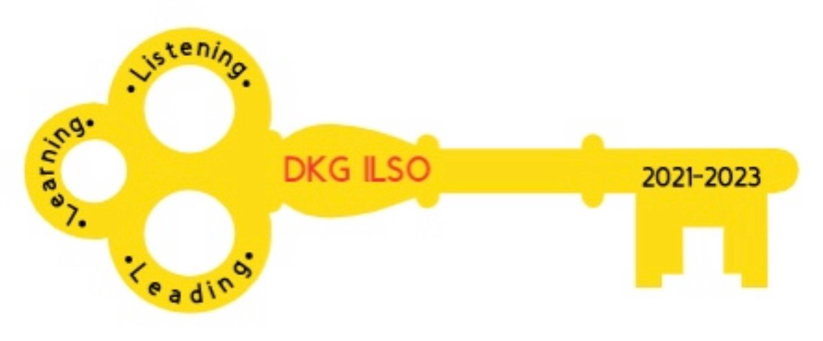
Illinois State Organization, ALPHA DELTA CHAPTER # 28 Cook County, Illinois
Mission: The Delta Kappa Gamma Society International promotes professional and personal growth of women educators and excellence in education.
Vision: Leading Women Educators Impacting Education Worldwide

Dear Alpha Delta Chapter Members,
Happy Birthday Greetings

November- 04 Joanne Kiewicz 07 Brenda Harris, Peggy Jackson-Edwards

December-10 Ellie Sotirova 24 Liane Troy 31 Beverly Bennett

Listening, Learning and Leading

We are thankful to be able to share a recording of Ewa’s presentation on her passion for saving the rainforest presented at our previous meeting. Kim created the link and QR code below to help you access the presentation. For those of you who have not used a QR code before, just go to your camera on your phone and take a picture of the black and white box with the dinosaur below. The video pops up like magic. To support rainforest preservation actions via donation please visit rainforesttrust.org

https://bit.ly/rainforesttrustDKG

Chapter Chairs- Send your written report to Pat Mizerka, Cindy Roder and Donna Soukup by November 9, 2021.

Alpha Delta Chapter

Let’s give a big shout out to the 2020-2022 Alpha Delta Chapter Nominations Committee Pat Gaines, Rosemary Smith, Barbara Martin, Lorraine Stastny who are pleased to announce the following slate of officers for the 2022-2024 biennium. Please notify Chair Patricia Gaines by December 1, 2021, if there are any other candidates you wish to nominate for these positions. Remember, candidates must have given their permission to be considered. Voting will occur in January.
Nominations Slate of Elected Officers – 2022-2024

Co-Presidents

Dr. Patricia Mizerka * * * Cindy Roder

1st Vice-President

Gretchen Alexander
2nd Vice-President

Christiane Jochimski

Recording Secretary

Dr. Roxanne Owens

Corresponding Secretary

Joanne Kiewicz

Chapter Program, Saturday, November 13, 2021 at 10:00

Kim Malinowski, our Communications and Marketing chair, will present our program, Zoom breakout rooms. Kim will guide us in using breakout rooms. Look forward to an informative and surprising session.

Chapter 80th Celebration

We will be celebrating our chapter’s 80th anniversary on November 8, 2021. Please have ready your favorite beverage and goodie to create a virtual tea party. The link below will provide you pages of tea cups to color. https://www.doverpublications.com/zb/samples/82294x/sample7c.html
Select one page, color it and have it ready to show on the 13th. Your coloring page submission will be entered into a $5.00 Dunkin Donuts e- gift card drawing. We will select 3 winners.

Very Important Information Regarding Contact Information
◆ Changes to emails and addresses should be sent to Dr. Kammie Richter, Editor, dkgilso.editor@gmail.com immediately so the members will continue to receive The Newscaster.
◆ Changes to emails and addresses should also be sent to our State Treasurer, Vicki
Smith, vlsteach@yahoo.com
◆ Changes to emails and addresses should be changed on the international website at dkg.org. You will need your DKG member number to log in. Your member number can be found in your yearbook.

Below is a draft of dates for our joint Zoom meetings:

MONTH | DAY | TIME | KAPPA | ALPHA DELTA | ETA | TOPIC
NOV | 13 | 10:00 AM |  | X |  | ZOOM BREAK-OUT ROOMS
NOV | 16 | 7:00 PM | X |  |  | Anxiety/Bev Johns
DEC | 4 | 10:00 AM |  | X |  | How to Make  Pierogi
DEC | 11 |  | X |  | X | Virtual Holiday Party
JAN | 18 | 7:00 PM | X |  |  | Scams/Sheriff Aimee
JAN | 22 | 10:00 AM |  | X |  | 80 years of Alpha Delta
FEB | 7 | 7:00 PM |  |  | X | Zentangle/Pam
MAR | 5 |  |  | X |  | CCCC
MAR | ?? | ?? | X |  |  | Chair Yoga
MAY | 7 | 10:00 AM |  | X |  | Diversity & Equity
MAY |  |  | X |  |  | CTPF Update
JUNE | 11 |  |  | X |  | EXECUTIVE BOARD

Grant Funding Opportunity
If you know any working Chicago Public School teacher, please encourage them to apply for the Rotary Club Grant of $3000.00 using this link. Applications are due by December 1, 2021.
https://rotaryone.org/cps-opportunity-grants/?fbclid=IwAR29TgqueACMnpb4A9TUFSXCLpLxC6qKL55TUeC5R4Ddw1TufED59BNI1X0

*Illinois Resources

Zoom sessions YouTube Channel
nuchapterdkg@weebly.com Delta Kappa Gamma, Illinois, key women educators

Women in the Arts Facebook DKG Facebook
DKG-ILSOWIACAR DKG Illinois key women educators

*We hope you have visited the chapter website at www.alphadelta-il.weebly.com and we encourage you to tell your friends all about us!

*For All Shoppers – DKG receives a small donation from Amazon when we shop through smile.amazon.com. 0.5% of your purchase will be donated to DKG Supporting Corporation which supports many of our DKG funds. To start your AmazonSmile account, go to dkg.org and click on About Us>How To Become A Member>Discounts. Then, select DKG Supporting Corporation as your charity. HAPPY SHOPPING!

Do you have unused gift cards to Walmart, Sam’s Club or Target to spare? If so, send them to Hugs for Our Soldiers (HugsForOurSoldiers.org)! The non-profit organization will use them to buy items for the care packages they ship to troops deployed overseas. Mail cards to P.O. Box 532, Vonore, TN 37885

“There are far greater things ahead than any we leave behind” -C.S. Lewis
We hope everyone continues using healthy practices to stay safe and well.
Wishing good health and safety to you and your family!
Cindy Roder and Donna Soukup, Co- Presidents

