Alpha Delta Newsletter - - September & October, 2021 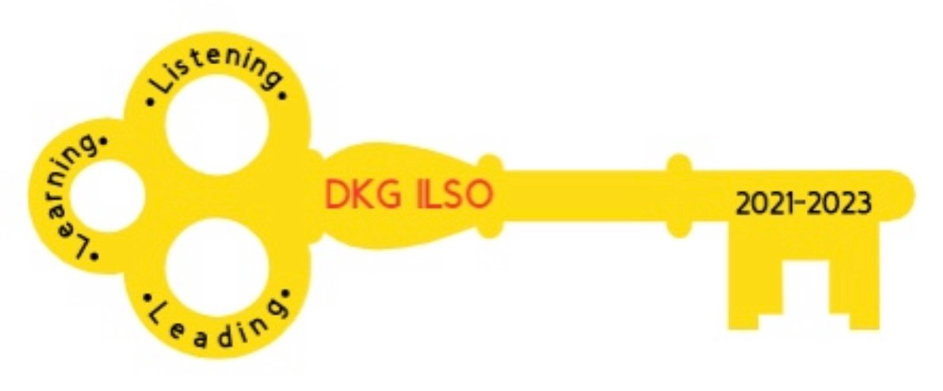
Illinois State Organization, ALPHA DELTA CHAPTER # 28 Cook County, Illinois
Mission: The Delta Kappa Gamma Society International promotes professional and personal growth of women educators and excellence in education.
Vision: Leading Women Educators Impacting Education Worldwide

Dear Alpha Delta Chapter Members,
Happy Birthday Greetings

September- 04 Gretchen Alexander

October-12 Maria Garcia 26 Pat Gaines 30 Ann Hennessy

Our Finance and Executive Board members have been busy working on a budget and upcoming programs. We will be teaming up with Eta and Kappa to provide you with many zoom opportunities. Due to fewer chapter members and rising costs we will be talking about a
$ 10.00 raise in our dues next year so that we can continue providing wells in Malawi.
WE are pleased to announce that our chapter participated in the $15K in 15 Days MATCH campaign for Marion Medical Mission where we have purchased a well for numerous years. Our donation will provide 2 wells instead of 1 well this year. Thank you finance and executive board for making this happen.

President Joan Rog showed us the new pin for her biennium. It is a silver key for $5.00

We will be celebrating our 80th chapter birthday on November 8, 2021. Please bring a beverage and goodie to our zoom meeting on Saturday, November 13 to help celebrate, Kim will be doing our break out program.

Permission to Post
Please take the time to fill out our “permission to post” form online to indicate if we are able to post your name and photo in DKG.ILSO publications. If you do not have access to a computer or smartphone to fill this out, please call Cindy (773-398-2762). The link to the permission to post form is below:

https://docs.google.com/forms/d/e/1FAIpQLSduOZwXH0K_DzLNi3LadkrDHVPY9sEdayYDY2BGPDuDMNuKFg/viewform?usp=sf_link

Very Important information regarding contact information
◆ Changes to emails and addresses should be sent to Dr. Kammie Richter, Editor, dkgilso.editor@gmail.com immediately so the members will continue to receive The Newscaster.
◆ Changes to emails and addresses should also be sent to our State Treasurer, Vicki Smith, vlsteach@yahoo.com.
◆ Changes to emails and addresses should be changed on the international website at dkg.org. You will need your DKG member number to log in. Your member number can be found in your yearbook.

Below is a draft of dates for our joint Zoom meetings:

MONTH | DAY | TIME | KAPPA | ALPHA DELTA | ETA | TOPIC
SEPT | 15 | 7:00 PM | X |  |  | Lemons to Lemonade/ Bev?
OCT | 2 | 10:00 AM |  | X |  | RAINFOREST
OCT | 12 | 7:00 PM | X |  |  | Citizen Soldiers
NOV | 13 | 10:00 AM |  | X |  | ZOOM BREAK-OUT ROOMS
NOV | 16 | 7:00 PM | X |  |  | Anxiety/Bev Johns
DEC | 4 | 10:00 AM |  | X |  | How to make pierogi
DEC | 11 |  | X |  | X | Virtual holiday party
JAN | 18 | 7:00 PM | X |  |  | Scams/Sheriff Aimee
JAN | 22 | 10:00 AM |  | X |  | 80 years of Alpha Delta
FEB | 7 | 7:00 PM |  |  | X | Zentangle/Pam
MAR | 5 |  |  | X |  | CCCC
MAR | ?? | ?? | X |  |  | Chair Yoga
MAY | 7 | 10:00 AM |  | X |  | Diversity & Equity
MAY |  |  | X |  |  | CTPF Update
JUNE | 11 |  |  | X |  | EXECUTIVE BOARD

Literacy News
Our state literacy members met to select books for us at the ILSO Convention next April, 2022. For those that crave non-fiction, the 2 022 book is ‘Radium Girls,’ by Kate Moore; the fiction selection is ‘The Book Women of Troublesome Creek,’ by Kim Michele Richardson. You will see a completed list of books considered in the Winter Newscaster article.

*Illinois Resources

Zoom sessions YouTube Channel
nuchapterdkg@weebly.com Delta Kappa Gamma, Illinois, key women educators

Women in the Arts Facebook DKG Facebook
DKG-ILSOWIACAR DKG Illinois key women educators

*We hope you have visited the chapter website at www.alphadelta-il.weebly.com and we encourage you to tell your friends all about us!

*For All Shoppers – DKG receives a small donation from Amazon when we shop through smile.amazon.com. 0.5% of your purchase will be donated to DKG Supporting Corporation which supports many of our DKG funds. To start your AmazonSmile account, go to dkg.org and click on About Us>How To Become A Member>Discounts. Then, select DKG Supporting Corporation as your charity. HAPPY SHOPPING!

Do you have unused gift cards to Walmart, Sam’s Club or Target to spare? If so, send them to Hugs for Our Soldiers (HugsForOurSoldiers.org)! The non-profit organization will use them to buy items for the care packages they ship to troops deployed overseas. Mail cards to P.O. Box 532, Vonore, TN 37885

“There are far greater things ahead than any we leave behind” -C.S. Lewis
We hope everyone continues using healthy practices to stay safe and well.
Wishing good health and safety to you and your family!
Cindy Roder and Donna Soukup, Co- Presidents

