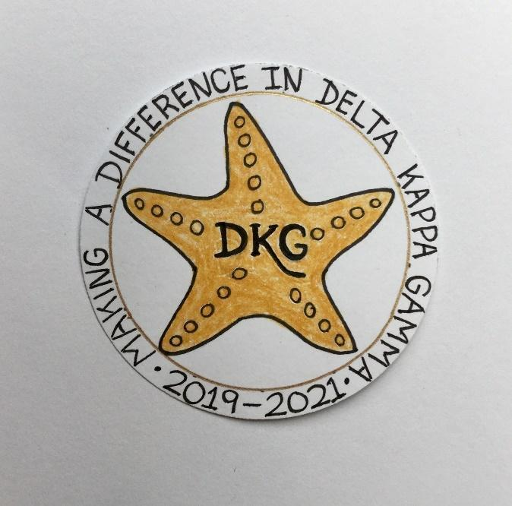
Alpha Delta Newsletter - - March & April, 2021
Illinois State Organization, ALPHA DELTA CHAPTER # 28 Cook County, Illinois
Mission: The Delta Kappa Gamma Society International promotes professional and personal growth of women educators and excellence in education.
Vision: Leading Women Educators Impacting Education Worldwide

Chapter Theme: Sharing our choices for action
Chapter Focus: Making a regional and global difference

Dear Alpha Delta Chapter Members,

Happy Birthday Greetings

April- 1 Denise Gamble, 26 Samatha Denson
28 Rita Dawkins

The dates for our Zoom meetings are as follows:

-Saturday, March 6, 2021 CCCC Wilmette Country Club via Zoom Your zoom link has been sent in a separate email.

-Wednesday, March 10, 2021 7pm Kim Malinowski will be doing a workshop on How to do breakout sessions for all interested DKG members throughout the state.

-Saturday, May 8, 2021 at 10:00 a.m. Our program will be a powerpoint Necrology for Diane Zmaczynski and Luba Johnson and Dr. Loretta Nolan.

Permission to Post
Please take the time to fill out our “permission to post” form online to indicate if we are able to post your name and photo in DKG.ILSO publications. If you do not have access to a computer or smartphone to fill this out, please call Cindy (773-398-2762). The link to the permission to post form is below:

https://docs.google.com/forms/d/e/1FAIpQLSduOZwXH0K_DzLNi3LadkrDHVPY9sEdayYDY2BGPDuDMNuKFg/viewform?usp=sf_link

Convention 2021
You received a March 2021 State President’s Message forwarded from Cindy listing the upcoming convention schedule. There are so many choices for us to enjoy. Please register for convention 2021. Since there are no fees for staying at a hotel you will be asked to choose and make a donation of your choice to any or all the funds listed. Your Newscaster has a full listing of sessions and registration form.

Chapter Connect
From our December 2020 Chapter Checkup- It is critical that you get your chapter members to update their profile on Chapter Connect on the DKG international website. We have discovered that International’s database has omitted some long time members from the list and luckily we were able to catch that in some cases, but there remain issues and we need you to ask your members to connect on the DKG International site. Bev has created a YouTube Video on how to do that and you can find it on our YouTube Channel at Delta Kappa Gamma, Illinois, key women educators.

Our DKG Cookbook will be available this spring both in hard copy @ $15.00 and a ecopy/pdf @ $5.00 or both for $18.00 (p. 11 Newscaster). LaVonne Cheney, lavonnec45@gmail.com has received over 200 recipes.

One of my favorite recipes that I use all the time is for salmon.

INGREDIENTS
1 tablespoon garlic powder 4 (6 ounce) salmon
1 tablespoon dried basil 2 tablespoons butter
½ teaspoon salt 4 lemon wedges

DIRECTIONS:
- Stir together the garlic powder, basil and salt in a small bowl; rub in equal amounts onto the salmon filets.
- Melt the butter over medium heat; cook the salmon in the butter until browned and flaky, about 5 minutes per side. Serve each piece of salmon with a lemon wedge.

*Illinois Resources

Zoom sessions
nuchapterdkg@weebly.com

DKG Facebook
DKG-Illinois key women educators

Women in the Arts Facebook
DKG-ILSOWIACAR

YouTube Channel
Delta Kappa Gamma, Illinois, key women educators

March Challenge: Learn a New Skill!
Get off to a fresh start this year by making an effort to learn a new skill.
Contact President Bev to sign up at pres.lambda.il.state@gmail.com

April Challenge: Stretch and Breathe
Improve your well being by doing some stretching or yoga exercise each day. Chair yoga is a possibility for those who need something less challenging. A little stretching can make a big difference in our health. Deep breathing is a key to mindfulness so make it a part of your day.
Contact President Bev to sign up at pres.lambda.il.state@gmail.com

*We hope you have visited the chapter website at www.alphadelta-il.weebly.com and we encourage you to tell your friends all about us!

*For All Shoppers – DKG receives a small donation from Amazon when we shop through smile.amazon.com. 0.5% of your purchase will be donated to DKG Supporting Corporation which supports many of our DKG funds. To start your AmazonSmile account, go to dkg.org and click on About Us>How To Become A Member>Discounts. Then, select DKG Supporting Corporation as your charity. HAPPY SHOPPING!

Do you have unused gift cards to Walmart, Sam’s Club or Target to spare? If so, send them to Hugs for Our Soldiers (HugsForOurSoldiers.org)! The non-profit organization will use them to buy items for the care packages they ship to troops deployed overseas. Mail cards to P.O. Box 532, Vonore, TN 37885

“There are far greater things ahead than any we leave behind” -C.S. Lewis

We hope everyone continues using healthy practices to stay safe and well.
Wishing good health and safety to you and your family!
Cindy Roder and Donna Soukup, Co- Presidents

