Alpha Delta Newsletter - - July, 2019 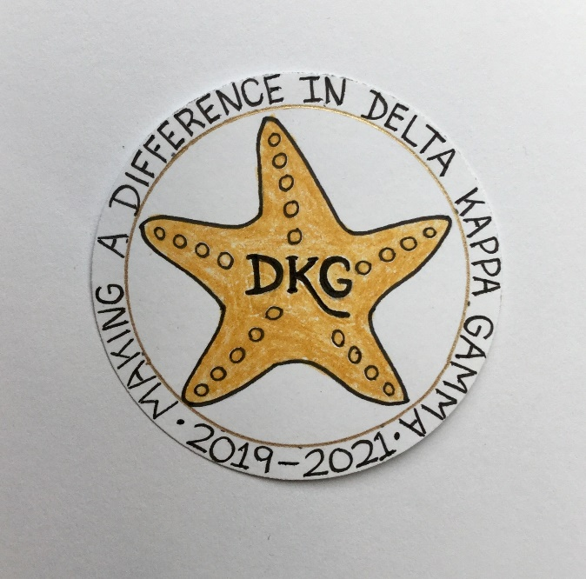
Illinois State Organization, ALPHA DELTA CHAPTER # 28, Cook County, Illinois
Mission: The Delta Kappa Gamma Society International promotes professional and
personal growth of women educators and excellence in education.

Vision: Leading Women Educators Impacting Education Worldwide

Dear Alpha Delta Chapter Members,
How exciting it is to begin another year with each of you in our DKG Society! Let us continue assisting others by donating books and toiletries, volunteering, tutoring, mentoring and supporting our chapter projects!

Sixty-five ladies and one gentleman (husband of President Debra LeBlanc) attended the 40th Anniversary of the Creative Arts Retreat at Allerton Park in Monticello, Illinois on June 28-30, 2019. We had a marvelous time. There were 20 first timers who joined in the fun. The theme, “Over the Rainbow in Ruby Slippers” allowed us to “follow the yellow brick road” as we dressed in Wizard of Oz costumes, enjoyed all entries in Professor Marvel’s Variety Show (which highlighted various talents of the participants), and created several masterpieces during the workshops. While there were four buildings for rooming accommodations, President Pat booked early and had a lovely room in the Mansion (where all activities occurred). Some comments expressed by the participants on the differences between the Lorado Taft campus and Allerton were: 1) gee - we don’t have to make our own beds, 2) so nice to have all meals and events in one place, 3) I don’t think we will miss walking all around campus in the rain, sleet, snow, or burning heat to get to each workshop.

“Making A Difference in Delta Kappa Gamma” is the theme selected by our 2019-2021 Illinois State Organization President, Beverley Johns. Her logo has the theme surrounding a DKG starfish. She has asked three chapter members to serve on state committees: Cindy Roder on Educational Excellence; Patricia Gaines on Personnel; and Donna Soukup will continue to serve on the Achievement Award committee.

The chapter Executive Board is continuing to plan for 2019-2020, the 2nd year of our Alpha Delta Chapter biennium. Our goals include having interesting, informative programs and finding meeting venues that are north, south and centrally located to accommodate all members. We have selected Saturdays for all of our meeting dates to avoid “after school” and “late evening driving.”

Membership News – We welcome back former member Valerie Davis! She was initiated into Alpha Delta Chapter in 2001. After several “return” visits since 2017, we are delighted that Valerie has renewed her membership in our chapter!

Be prepared to respond “positively” to Nominations Chair Donna Soukup and Cindy Roder as they seek new chapter officers for the 2020-2022 Biennium. Note that International President Cathy P. Daugherty states on page 6 in her article “Carpe DKG!” in the Collegial Exchange 2019 Volume 85-4 DKG Bulletin – that members should “be open to taking on new endeavors. That’s how you grow. That’s how you strengthen your chapter, too. Find something that will make you say ‘YES!’ You never know where it will lead. Take advantage of opportunities.”

Reminders and Upcoming Events – Please set your calendars:

- Yearbooks will be distributed at the first meeting on September 28, 2019.

- A Chapter Memorial Service for dear member, Carole J. Ireland, who passed on March 5, 2019, will be held during the November meeting. She also will be included in the 2020 Illinois State Organization Celebration Service during the State Convention in St. Louis. Memorial donations may be sent to Treasurer, Lynne White.

- To All CCCC Chapter Achievement Awardees – We are only missing the Chapter Achievement Awardees for the following four years: 2003; 2004; 2008; and 2010. PLEASE LOOK on the back of your award medallion - as the year may be engraved on it or CHECK the date on your certificate. Then, please notify President Pat - ASAP - to confirm your date.

Happy Birthday Greetings

July – Nancy Mayer, Deidre Taylor-Cubias, Brenda Duncan, Cindy Roder

August – Ruth Ortigoza, Li-Wei Peng, Dorothy (Judy) Flynn, Angela Thomas

September – Gretchen Alexander, Marie Feltus

Warmest wishes as you enjoy these summer days!

Pat Gaines

